THE ILFORD BLUE

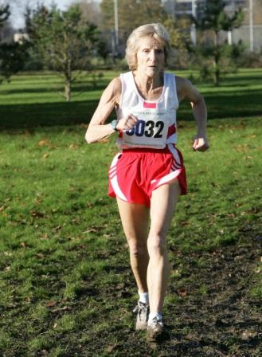
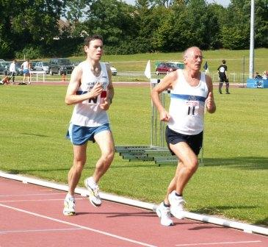



Club House 88a Lambourne Road Chigwell Row

Website www.Ilfordathleticclub.org.uk Issue No 2
Cover Picture: Two of Ilford’s golden oldies - Pam. competing for England in the Dublin International Cross Countrty .Old Favourite Tony Nixon returns to serious competition at the SML Basingstoke.
EDITORIAL

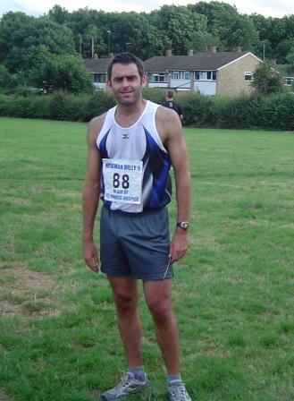
Hello and welcome to the second edition of the club magazine, ”an amalgam of literary slapstick and the occasional athletics article”, the much maligned and scurrilous pamphlet, entitled ”The Ilford Blue (already known by its acronym TIB) ”. The first issue seems to have been so well received that my litigation lawyers have given the green light to go for another – Ok I grant you there was a bit of a kerfuffle from the walking section regarding the editorial’s toilet humour. However let me categorically state that, notwithstanding, I want to flush all that all away and get down to the business in hand. No edition would be complete without a picture of our local star Rocket Ronnie and he duly obliged us with this stunning picture taken after the Newman Hilly 5. Actually now I remember he did go off a bit too hard for my liking but as you can see he seems to have kept it up right to the end.

But what of the athletics I hear you say and “Yes” 2005 did produce some. Unfortunately with many of our more established stars either injured or unavailable the club has had to dig deep this year. The senior men comfortably retained their SML division 1 status in track and field, and we continue to pick up medals on the road, albeit sporadically. Gone are the halcyon days when a Gainsy “ Sea of Blue and White” would sweep majestically down the Southend sea front but they will return I can assure you.
Again in cross country we continue to close two men’s teams and a Ladies team at each venue but we again rely on the bread and butter athletes of the club. Are we spread to thinly? – No! Hats off to them I say. Hoorah! The Ladies squad continue to improve, training enthusiastically and with many personal bests set over the year and I must add across the whole range of disciplines and distances (even race walking). I feel we are very near to boasting a very formidable ladies section.

Finally one has only to enter the Cricklefields Stadium on a training night to sense the “buzz” that is going on with the Young Athletes. Craig’s group of sprinters immediately impress with their enthusiasm and willingness to learn. The under 17 men’s sprint squad deserve the highest of plaudits. The ever ebullient Bob Few is now backed up by an enthusiastic and proficient coaching team and these ladies deserve special praise for the energy they are putting in to the “Young Rascals” group.
Finally Paul and Steve Cheal have worked tirelessly to promote the club within the schools and their notable contributions can be seen not only by the sheer numbers of youngsters on Tuesdays and Thursdays but by an increasing presence of Young Athletes in county and indeed national competitions. Well done to both.

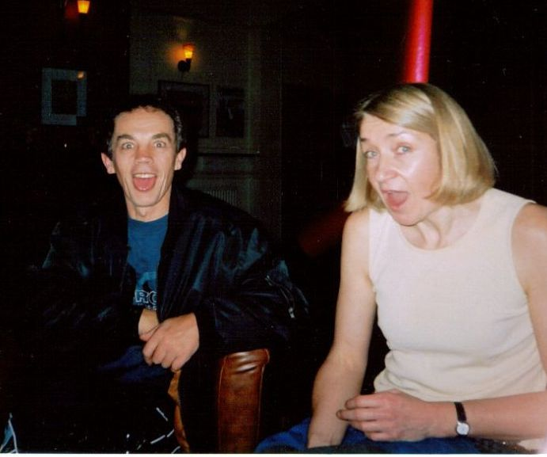
Bored yet? Here’s another picture to cheer you up: taken at the club’s Saturday Evening headquarters – The Red Cow- I think this was the point in the evening where Andy had just announced that Sheilagh said it was ok for him to stay out all night drinking. Anyway lets get on with the show

Martin


Below Track Star Rob Nixon, photographed here emerging from the Loughborough Seaman’s Mission of Excellence, demonstrates his unavailability for the Southern Men’s League When interviewed Rob replied “I guess my Dad has always been a sort of role model for me ”
OUR PRESIDENT CLAIRE

If you take more than a cursory look at our long list of past presidents you may realize that Claire’s election has a unique quality to it, well almost unique for it has happened only once before – intrigued?
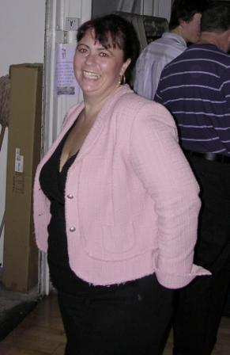
From a very early age athletics has filled a large part of Claire’s life, appearing at the trackside at ten days old and by four years of age judging race results by vest and skin colour, and soon after,by numbers. Assisted and nurtured by her parents Margaret and John Filmer and her ‘uncle’ Dennis Snow, Claire progressed to being the meeting runner between Track Steward and Recorder this included internationals at Crystal Palace which meant numerous long climbs up the stand stairs right to the top – how keen can you get! Nor was it all officiating for Claire had many a front row seat with father John and uncle Den at Crystal Palace international meets which meant close up inspection of, amongst many, the likes of Seb Coe, Steve Cram and our very own Wilbert Greaves.
Claire’s early start in officiating meant that at the age of fifteen she was able to take her judge’s exams resulting in her becoming the youngest Grade 4 officials judge in the South of England and officiating at the English Schools Championships. Today, Claire is now a Grade 2 (still the youngest in South of England) and officiates most weekends throughout the UK be it track, road or cross-country, including internationals and occasionally can be seen briefly on TV or in the background of weekend newspaper sports photos.
Born in Hainault, in July 1972, delivered by her Dad and a fortunate late appearance of a local midwife Claire’s arrival was, to say the least, surprising for she was unexpected! Fortunately her two elder sisters, Helen and Sue, came to the rescue for despite the lack of preparation for a new arrival Claire was soon the best dressed baby in Hainault.
In the early days Claire went to the track a lot with father John where he would help Freddy
Plumm with the coaching, she is always reminded by family about the times, where she would sit on the track and do the hurdle warm up exercises with Wilbert and then follow Roger Mills around the track whilst he was race walking, with her wiggly bum!!! (her words). At this time she also belonged to 1st Hainault Girls Brigade and was part of their band where she played the bugle, side drum & bass drum although finally because of the weekend clash of interests she had to make a choice between the brigade and athletics, and of course the latter won.
From a very young age the field events intrigued Claire and she spent many an hour begging to be allowed to throw a shot or even a hammer (even though girls weren't allowed). Eventually at the age of 11 father John agreed she could try her hand at competing, becoming a full member of Ilford AC under the coaching arm of Joe Jalowiecki Claire concentrated on the shot and discus and the occasional javelin competing in Young Athletes and Woman’s Southern Leagues for the next 6 years. During much of this period Claire was both officiating and competing in the same meetings and remarkably at the age of 15 she did just this in both the Essex county champs and also the Essex Schools – again, how keen can you get!
School time also provided Claire with the opportunity to shine. At primary school she won a cup for outstanding sports girl of her year. At junior school, she took part in lots of running events, a number being district sports held at Cricklefields and also netball where she played for the school team in many competitions. At Senior school Claire took part in even more sports, including athletics, netball and hockey, representing the school in all of these activities and winning a trophy in her 4th year for her services to sport within school.
Finally when Claire was about 15, they brought in the hammer for girls so, at long last, she had the opportunity to try her hand at the event she had always wanted to do – father John always reminded her that she was about 3 year's old when she first tried to pick up a the hammer, it was a remarkable feat that she was even able to drag it along for it was bigger than she was!.
For the next couple of years Claire juggled her time between competing and officiating, until at the age of 17 she fell ill to a serious virus which affected her hip, leaving her unable to walk for a long period of time. Hospitalized for several months it involved being pushed round in a wheelchair with months of physio to get her hip back moving again. Claire has one memory from this time of illness which is going down to the track on a Tuesday evening with father John, all wrapped up in her wheelchair watching everybody train, and then once it was all over being pushed around by John Kenny whilst he warmed down - even when she was ill she couldn't keep away. Once recovered she did start competing again, but the throwing wear and tear on her hip became too much to bear and so,reluctantly, Claire decided to take early active athletic retirement and concentrate on her officiating full time.
Considering Claire’s main interest in athletics is in field events, her heroes of the sport come from both track and field. Ilford AC heroes include John Kenny, who became a close friend and spent many times travelling from meeting to meeting as they grew up, also Wilbert whom she spent time with when growing up doing her hurdling exercise whilst he did his!!! Some of her other heroes within the sport from the UK include Tessa Sanderson, Daley Thompson, Colin Jackson, Steve Backley, Roger Black, Kelly Holmes and Paula Radcliffe. From the more international aspect of the sport heroes include Merlene Ottey (also a favorite of father John), Michael Johnson and Maurice Greene.
From the good times of those mentioned above we now have in the present time many a disgraced top athlete, some are national and world champions and Claire finds it hard to understand the need to enhance performance with drugs. As she says, “ I think once somebody has been caught taking drugs, I do not feel as though they should be allowed to compete in athletics again, whether that be on behalf of a club or their country. If they can do it once, what is stopping them from doing it again - I also feel that it is not a good advertisement to the young athletics of today, they probably think if their heroes can get away with taking drugs why can't we” - sentiment I think none will disagree in, our club at least.
Claire also considers a less damming aspect of our sport, but none the less pertinent, namely pacemakers, again this was not something that was used in the past, so why is it used now. Claire likes it when on the odd occasion the pacemaker wins!
As president Claire is an active committee member and believes 2012 will be a big asset to the club - as we are local to where the Olympics will take place Claire feels that the club will benefit and that hopefully the plans concerning the redevelopment of the top field will come about, one which will attract new people of all ages and also provide training facilities for the period of the Olympics. Claire believes it will also be a milestone in the Club’s history if our youngsters of today are involved in 2012.
For Claire motivation with regard to officiating involves all kinds of aspects. She enjoys the traveling around to different parts of the country, attending different meetings, from local grass root athletics to the internationals, meeting a variety of people and over the years, watching many of the youngsters work their way through the ranks from young athletics up to seniors especially some of the talented youngsters making into junior or senior internationals. Even whilst she officiates she enjoys the challenge, not knowing from one meeting to the next what is going to happen - there may be an incident which you need to resolve or even a world record broken to be verified. Another aspect has been the opportunity through athletics to meet many wonderful friends whom she has grown up with since my childhood - and these, like for many of us from the world of athletics, have been a large part of her life, many from within Ilford AC but also from other clubs within the county.
Over the next couple of years she would like to do a lot more meetings, and hopefully move from her current grade to a grade 1 track official - it would be her dream to be part of the Olympics in some form or other of officiating, and hopefully because of her age, this will be something that is achievable
It would also be nice to travel abroad to have the chance to officiate, when on holiday she has visited some tracks abroad, and having seen some of the facilities, especially in some of the third world countries, she starts to appreciate how lucky we are with the facilities we have.
On a family note, happily married Claire met her Husband in 1990 where they started off as friends – finally getting together in 1994 when she was 22 and marrying in1998. Losing her father in1998 was a very hard time for Claire and it was at this time when she thought about packing it all in, as she didn't think she could go on without him being around, but after a lot of heart searching decided to carry on, as this is what he would have wanted.
Claire as we all know has carried on often with mother Margaret in tow at many of the events, in all weathers, including many a time getting absolutely saturated in the middle of the summer! Claire now officiates at many big southern events both indoor and out and has also refereed many county events, including the Essex Schools county indoor championships.
Claire says that accepting the presidentship has been a great honour and hopes that both Mum and Dad are especially proud of her.
Claire have a lovely presidential evening at the Club’s annual Dinner and Dance in March, enjoying all the attention of your family, friends, guests, club members and colleagues.

Finally if you haven’t already realized, Claire is only the second member to follow in the presidential footsteps of a parent, the other being Andy following father Jimmy Catton (1958/9). John Filmer who was president in 1992/3 was a hard working track, road and cross country judge and yes Claire, Dad would have been very proud.
Gerry Pells

NEWMAN HILLY 5 06//07/05 Hainault Country Park
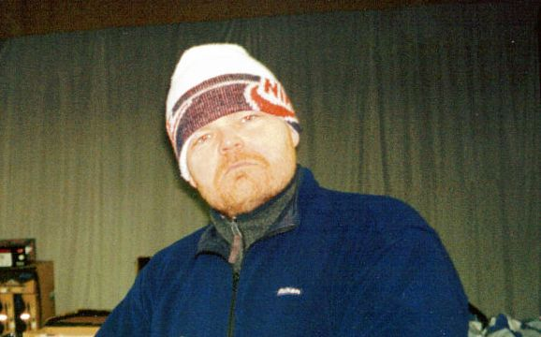

Newman Hilly 5 mile Race:-
No less than 30 athletes from the host club contested Ilford AC's Newman Hilly 5 mile "off road race" held on the paths and tracks of Hainault Forest on Wednesday night. Iain Campbell once again proved to be the soup of the day as he broke away from his pursuers towards the end of the first of the 2 demanding laps. Campbell had built up a 50 metre lead as he attacked the last hill towards the finish leaving teammate Malcolm Muir to battle with Woodford Green's Matt Flannelly for 2nd place. The habitually garrulous Flannelly had employed his normal tactic of talking all the way round in an effort to psyche the Ilford Man out but was left chewing on his words as Muir turned on the gas in the final 100metres.
International triathlete Karen Sindall expectedly took the women's race in a time of 31.07 and 10th place overall. East London's Karen Levenson was 2nd and Ilford's Bree Nordin 3rd.Snooker ace Ronnie "the Rocket" O'sullivan lived up to his nickname blasting around the course to finish in a fine 6th position recording 30mins 21secs.
The race held in memory of Newman Sargent attracted over 100 entrants raising some £500 for St Francis Hospice. Prizes were presented afterwards by Club president Wes Clarke.
Ilford times and positions:- 1st Iain Campbell 27.33, 2nd Malcolm Muir 27.53, 7th Matt Maple 30.34, 10th Karen Sindall 31.07, 15th Abdi Berleen 32.25, 22nd Alan Lattimore 34.11, 23rd John Mackenzie 34.22, 25th Darren Botterill 35.03, 27th Bree Nordin 35.24, 28th Rohan Alexander 35.39, 30th Iain MacDonald 36.32, 34th Keelie Brooks 37.07, 38th Ray Rawlinson 37.44, 39th Peter Spelman 37.51, 40th Pauline Tester 37.56, 41st Gary Webb 38.05, 42n2 Paul King 38.18, 46th Henry Ricketts 38.26, 48th Ken Hylton 38.51, 49th Sally Gillam 38.56, 53rd Owen Phipps 39.26, 67th Pam Jones 41.09, 68th Micky Webb 41.18, 73rdVincent Hehir 43.06, 76th Joan De'ath 43.41, 73rd Gerry Pells 44.12, 86th Pete Whiting 49.21.
Presentation to Saint Francis Hospice 25th August 2005
For the last two years Ilford Athletic Club have raised funds for Saint
Francis Hospice following the support given by the hospice to one of our
former members Newman Sargent. Newman was a committed and enthusiastic club
member and long time motivational road & cross country team manager.
We have done this by donating the surplus from our annual "Hilly Five" race
in Hainault Forest to this worthy charity. This year we have raised £464.53
for St Francis Hospice.
Saint Francis Hospice has now been open for 21 years and during that time
has given care and support, free of charge, to many thousands of local
people, who have cancer, motor neurone and other life limiting illnesses.
The aim of the hospice is to relieve pain in all its forms, whether it is
physical, social, emotional or spiritual. As a local registered charity they
depend upon the support of the surrounding community for 65% of their total
income.
A quote from Newman's widow:
" St Francis gave back Newman his dignity, comfort and peace, and for both
of us gave us the precious time we needed together for the three weeks
before he died. In that time we were helped enormously both physically and
emotionally for what was about to come, and for that I will always be
indebted to them."

CAPTION C0MPETITION
A Substantial prize is being offered for the best caption to the picture below - Entries to the Editor. Winner will be announced in the next issue.
Suggestions received so far include:-
Mine went this big in the cold of Great Notley
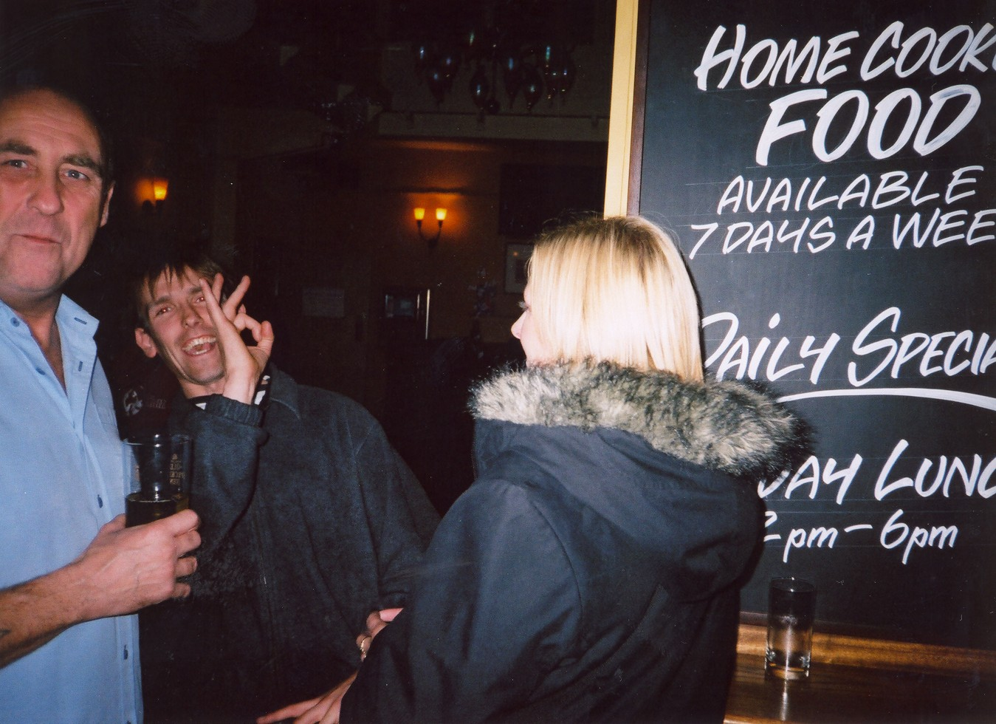
Matt prepares to check Malc for hidden drugs at Gloucester Park

Oh Blimey They’re getting away
Sit on him Rob

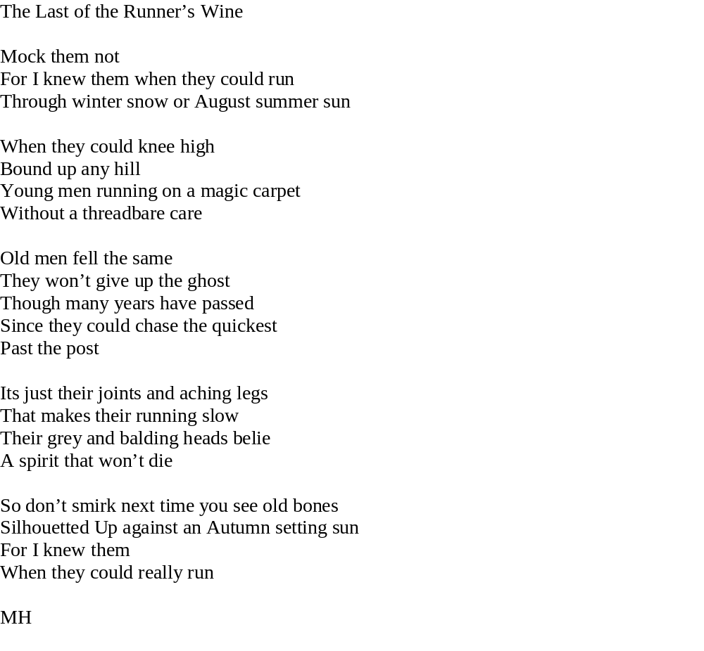

Donations to club since January 2005

ERNIE FARNHAM
JIM HUDDART
DOREEN SPARROW
JOHN BATCHELOR
KIM AND JACK WEBB
PETER DILLEY
ALAN THOMAS
LES HISLOP
RAY BETTS
COLIN FOX
FREDERIQUE LE CAR
KIM AND GARY WEBB
MARTIN ETCHELLS
MIKE HERRING
DOREEN SPARROW
ALAN LOVETT

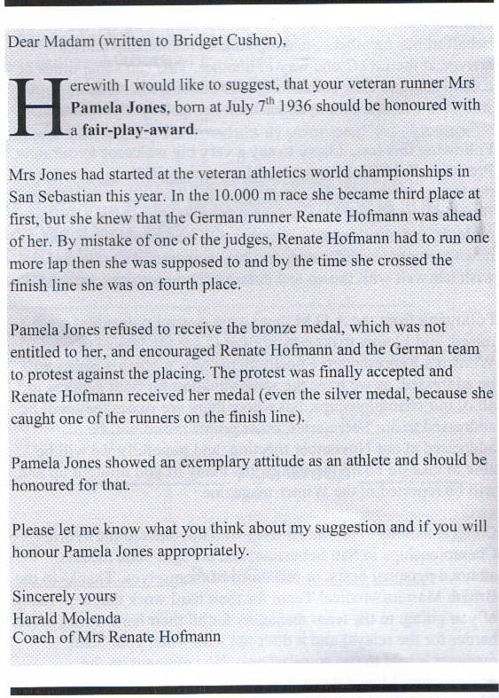
FAIR PLAY TO THE GIRL – FROM AUTUMN MASTERS ATHLETICS


ILFORD ATHLETIC CLUB
DINNER & DANCE


Friday 10th March 2006 7.00 for 7.30 start at
Woolston Hall Golf Club Chigwell.

Claire Levey our President 2004/2005 warmly invites you to attend the dinner and dance.
All members are welcome from the youngest to the eldest.

Numbers are restricted so book early to avoid disappointment, the price is
£ 30.00, please make cheques payable to Ilford AC.
Please contact the following Geoff Williams on 020 8500 3744,
For tickets. See enclosed Flyer.

Guest speaker is to be International hammer thrower WILBERT GREAVES

ILFORDOUTOFORDER

It was good to note that following Jocky’Campbell’s magnificent silver at the Essex vets xc championships at Chingford he was still able digest the local Rag’s race account concerning John Sear’s narrow victory with his customary good humour and I quote:_

“Staunch partisan propaganda from the local Woodford party publication, eh? Where is your Joseph Goebbels now?? We shall fight them on the beaches. (alas, not the Essex coastline, perhaps a stretch near Limerick)
"Sear makes light work of the course" maybe, but not an energy saving bulb I can assure you. Fireman Sam collapsed across the finishing line to "comfortably" retain his title, (having conceded defeat until the inspirational sight of his brother on the sidelines with 150 metres remaining). Campbell may have looked as comfortable as a dog being washed, but he is scurrilous, biting and BACK..... Oh I feel a lenghty tirade coming on....
ps I guess Scotsman haven't evolved much over the centuries and neither have sharks.”


Lord Haw Haw (aliasJocky Campbell)

DEVELOPMENT OFFICER REPORT

This must be a first for a report by a Development Officer better known as The Ilford Development Team consisting of Mike Sargeant, Coaching Co-ordinating Officer, Paul Cheal, School Liaison Officer and myself (Ian Gains)

LONDON BOROUGH OF REDBRIDGE
We have completed our first year in partnership with L.B.R. in Sports Hall Athletics League primary school level. The winning team, William Torbett, represented Redbridge in The London Youth Games finishing 8th out of 32 London Boroughs. The 7 teams above them were complete borough teams and not a school. A lot of praise must go to our coaches who put so much time and effort into this venue.

ILFORD PROMOTION DAYS

Back the Bid Olympics 2012 hosted this event. Sadly the weather was poor but 40 athletes attended for 4 hours.
ILFORD TOWN SHOW – It may have been a quiet weekend for shoppers but Ilford had hundreds of youngsters at our come and try events.

SCHOOLS – PRIMARY AND SECONDARY

We have now set up a club/school/borough link where our coaches work closely with schools in athletics development. Paul Cheal has successfully set up the Jack Petchey Awards.

YOUTH DEVELOPMENT COACHES

Starting with the Ilford Rascals Bob Few has now a team of ladies coaching his “Rascals” whose numbers are ever increasing.. Craig Burrow has just finished his first year coaching sprints and jumps. His squad gets bigger every week and he has an u17 boys 4 x 100 relay squad ranked one of the best in the UK.

Mike Sargeant (Sprints/Jumps) and Paul Cheal (Throws) – These two coaches have been the main driving force behind the increase in our young athletes.
Steve Cheal (Middle distance) – Paul has 2 very promising youngsters for the future and this is yet another area where our intake has improved.

Once again I would like to thank everybody who has supported our youth development programme. Before I go, Athletics Federations around the world have been Emailed informing them of who we are/ what we are/ where we are with a view to the 2012 Olympics

Ian Gains

TRIATHLON
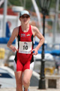
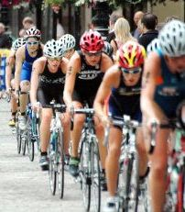

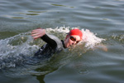

As most of you are already aware Karen Sindall is undoubtedly one of our most talented athletes and hope fully will fly the club’s colours in Beijing 2008 as well as in London 2012..
Karen returned from Sterling at the start of the year to train under the guidance of her coaches at home and intent on building up her fitness for the coming triathlon season.
Unfortunately Karen hit more injury problems with her Achilles and hip flexor which severely hampered her running fitness and limited her success this year.. Nevertheless she managed 2 top 10 positions in the prestigious Windsor and London Triathlons and was also going well in the ITU World cup at Salford before her injuries forced her to take the foot off the gas. Always a talented runner (Karen won the Southend 10k 2 years on the trot in times that nobody has since approached.) Karen’s biking improved beyond measure last year and together with her swimming background as a former county champion surely it can only be a matter of time before we see her at the top of the triathlon tree.
To this end Karen has now enlisted the services Jack Maitland who is the Head Coach at the British Triathlon High Performance Centre at Leeds Metropolitan University. Jack will pull the 3 disciplines together under a balanced and structured programme and we should soon start to see the rewards that Karen richly deserves. We should all try and support Karen in whatever way we can.

Tri Result

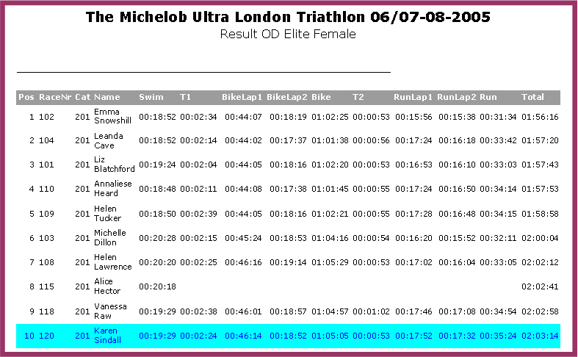

London Triathlon Press Report 7th August 2005
The London Borough of Newham, the Olympic Borough of East London played host to the Capital's first major event in an Olympic Sport since the 2012 bid win. Over 80,000 participants where cheered on by up to 35 thousand spectators and over a million watched what is now the largest triathlon in the world on BBC the following week.
In the Elite Women's race llford Triathlete Karen Sindall finished in an excellent 10th place. Based at the Excel centre Karen set off from the Royal Victoria Dock swim start in confident mood. An excellent swim saw Karen well to the fore in the 2nd group battling with eventual winner Emma Snowsill of Australia and last week's Salford ITU winner Liz Blatchford. Karen was aggressive throughout and left the water in a superb 6th place. However problems with the zip on her wetsuit meant she lost crucial places in transition and started the bike section in the 3rd pack instead of being on the heels of the leaders.
Karen continued to work hard on the bike section where she regained 6th place working with former winner Michelle Dillon and dropping Salford 4th placer Helen Lawrence in the process. Karen entered the run section feeling good but knowing that her running fitness is still a long way off her best following a year of injury. It was always going to be a damage limitation exercise as some of the faster girls started to close her down. Nevertheless the Ilford triathlete held her form together well and can be well pleased with her achievement.

Royal Windsor Triathlon 2005: Elite Results

Female
Pos. | Race No. | First Name | Last Name | Team Name | Swim | Bike | Run | Total
1 | 56 | Liz | Blatchford |  | 20:00 | 01:06:16 | 38:33 | 02:04:49
2 | 55 | Michelle | Dillon |  | 21:30 | 01:07:05 | 37:32 | 02:06:07
3 | 70 | Catriona | Morrison |  | 21:29 | 01:07:07 | 37:42 | 02:06:20
4 | 59 | Helen | Tucker | Giant Racing | 19:49 | 01:06:27 | 40:31 | 02:06:48
5 | 58 | Jodie | Swallow | Total Fitness Bath | 19:49 | 01:06:34 | 41:09 | 02:07:34
6 | 57 | Leanda R | Cave | Royales | 19:50 | 01:08:42 | 39:33 | 02:08:07
7 | 60 | Karen | Sindall |  | 21:14 | 01:07:12 | 41:10 | 02:09:36
8 | 61 | Helen | Lawrence | Royles | 20:57 | 01:09:57 | 39:47 | 02:10:42
9 | 67 | Yvette H | Grice | Bodyworks XTC | 21:34 | 01:09:58 | 39:49 | 02:11:23
10 | 75 | Steph | Forrester | Science in Sport.com |  |  |  | 02:12:05
Press Report 20th June - Windsor Triathlon
Ilford AC's elite triathlete Karen Sindall returned to form with a supeb 7th place in the searing heat of the Royal Windsor Triathlon on Sunday.
Set in the magnificent backdrop of Windsor Castle, Eton College and the majestic River Thames. The river swim is followed by a bike course that takes in a number of villages around beautiful Berkshire and returns through Windsor Great Park. The multi-lap run course winds around the Great Castle, over Eton Bridge and along Eton High Street, passing famous Eton College. The event takes in 900 years of British history!
Competing against the cream of the worlds best triathletes Karen emerged from the swim section held in the River Thames in the 2nd group just 1min 15secs down on the leaders. Karen then showed some of the strength she has recently developed on the bike when she dominated the second group on the 40k course speeding through the villages of picturesque rural Berkshire. The bike/run transition saw Liz Blatchford, Helen Tucker, Catriona Morrison and Jodie Swallow all contesting the lead. Karen led the 2nd group in with Michelle Dillon, Leander Cave and steph Forrester in close attendance.
The 10k run proved to be a demanding 3 lap affair over the tough undulations of the town centre and Eton College, made worse by temperatures well into the 30s. Dillon, Forrester and Cave quickly passed Karen as they tried to make up on Liz Blatchford who by now was beginning to establish a commanding lead. Unphased by this Karen, relying purely on basic running fitness as she has only recently begun speedwork, held her run together bravely in 8th place.
By the 5k mark Karen held a 30 sec gap on 9th place Helen Lawrence, a girl who had defeated her the previous week in Zundert Holland. By the last of the 3 laps the lead on Lawrence had not only stretched to nearly a minute but she was also beginning to reel in Scottish international Steph Forrester who was by now really beginning to suffer in the heat. Karen duly overhauled the struggling Forrester on Eton Bridge speeding through to the finish in a time of 2hrs 9mins for 7th place. Liz Blatchford won the race in 2.04.49 with Michelle Dillon and Catriona Morrison in 2nd and 3rd respectively.
A top 10 position now guarantees Karen a place in the Salford World Cup race on the 31st July which is likely to be the trial for the Commonwealth Games. Following an unsuccesful period training in Scotland all seems to be well now for the Ilford Athlete who is undoubtedly a lot happier training with her coaches at home.

2005 ITU Salford World Cup 2005-07-31
Results for: Elite Women
Position |  | Last Name |  | First Name |  | Country |  | Total Time |  | SWIM |  | T1 |  | BIKE |  | T2 |  | RUN
1 |  | Blatchford |  | Liz |  | GBR |  | 02:03:39 |  | 00:20:14 |  | 00:00:52 |  | 01:06:08 |  | 00:00:53 |  | 00:35:33
2 |  | Warriner |  | Samantha |  | NZL |  | 02:04:00 |  | 00:20:37 |  | 00:00:51 |  | 01:07:26 |  | 00:00:53 |  | 00:34:14
3 |  | Tucker |  | Helen |  | GBR |  | 02:04:06 |  | 00:20:12 |  | 00:00:56 |  | 01:06:07 |  | 00:00:56 |  | 00:35:55
4 |  | Cave |  | Leanda |  | GBR |  | 02:04:16 |  | 00:20:11 |  | 00:00:56 |  | 01:06:05 |  | 00:00:55 |  | 00:36:10
5 |  | Lawrence |  | Helen |  | GBR |  | 02:04:23 |  | 00:20:38 |  | 00:00:57 |  | 01:07:23 |  | 00:00:55 |  | 00:34:27
6 |  | Taormina |  | Sheila |  | USA |  | 02:04:31 |  | 00:20:17 |  | 00:00:56 |  | 01:06:01 |  | 00:00:53 |  | 00:36:24
7 |  | Dillon |  | Michelle |  | GBR |  | 02:04:41 |  | 00:21:15 |  | 00:00:57 |  | 01:06:42 |  | 00:00:54 |  | 00:34:51
8 |  | Di marco Messmer |  | Magali |  | SUI |  | 02:04:43 |  | 00:20:17 |  | 00:00:52 |  | 01:06:04 |  | 00:00:55 |  | 00:36:35
9 |  | Whitcombe |  | Andrea |  | GBR |  | 02:04:48 |  | 00:21:11 |  | 00:00:54 |  | 01:06:51 |  | 00:00:59 |  | 00:34:52
10 |  | Murua |  | Ainhoa |  | ESP |  | 02:04:54 |  | 00:20:34 |  | 00:00:58 |  | 01:07:22 |  | 00:00:53 |  | 00:35:06
33 |  | Sindall |  | Karen |  | GBR |  | 02:10:41 |  | 00:21:10 |  | 00:00:57 |  | 01:06:50 |  | 00:00:55 |  | 00:40:49
ITU World Cup Triathlon - Salford Sunday 31st July
Ilford triathlete Karen Sindall competed in the Elite womens race in Sundays ITU World cup triathlon at Salford Quays Manchester on Sunday. After a satisfactory swim in the 2 lap 1500 swim Karen emerged from the water in the middle of the pack but less than 50 seconds down on the leaders which included Leanda Cave, eventual race winner Liz Blatchford and ex Olympic Champion swimmer Shelia Taomina of the United States. Karen then worked her way into the 2nd group on the bike chasing a lead group of 5 reducing the lead to 40 seconds after the 1st of the bike loops. Karen held the front of the group for the 4 lap course and approached the T2 transition area looking like she was in good shape for a top 10 finish. However as she started her run she felt that the tank had run empty and together with a soreness in both Achilles she was forced to stop and stretch by the kerbside over Salford Bridge. Karen picked up her running on the 2nd and 3rd laps but in this company it was too late to make any impact. Nevertheless Karen remains optimistic she can overcome this setback before next Sundays London Triathlon where she will going again for a Commonwealth Championship qualifying performance.


Walkers News

Ilford A.C. Racewalking 2005

With the festive season upon us our Walking Section has much to celebrate and cheer us through the cold months of winter. Once again a ‘grand slam’ of all the local league championships has been accomplished. There have also been a good number of individual achievements which I will now attempt to cover and probably bungle with an omission or two. Here goes.

The Essex League Team Trophy was retained against little opposition. True it is a measure of our own strength but that must also be tinged with a little sadness that in the County of Essex we can no longer find the kind of team competition that nurtured our young talent in the past. If travel and adventure is your thing, then join the walking section. The Essex League of course encompasses the County Championships and in 2005 it must have seemed to others that Ilford were dividing up and sharing around most of the spoils. Before detailing these however I think that this would be the appropriate point to highlight two new major signings for the club, as both athletes feature amongst the individual County honours. May I first introduce Pete Ryan, GB International and formerly of City of Sheffield AC. Pete was National Long Distance Champion in 2003 when he won a 100 mile event at Newmarket in 19.57.35 from a large international field. Pete now looks forward to training with Ilford’s other current long distance GB International Kevin Marshall. I also extend a warm and welcome return to the club for former GB Junior International Scott Davis. Scott returns after a break from the sport of some 5 years and already his performances in the latter part of the season have fired the imagination and lifted the spirits of the British Racewalking fraternity. In only the second race of his comeback and in sizzling hot conditions at Earls Colne, Essex in early September, Scott won the National 50km Championship and Commonwealth Games Trial Event in 4.47.34. He was ably supported by Bob Dobson’s quite superb 7th place in 5.47.30 which gained Ilford the National Team Silver behind Leicester and also both the County and Southern titles. With this victory Scott also claimed both the Southern Counties and Essex Individual titles whilst Bob secured bronze and silver respectively. Following that race representation was made, on Scott’s behalf, to the Scottish selectors for the Commonwealth Games but without the required qualifying time for the 50km event they felt unable to consider selection. They will however be following Scott’s progress from here on very closely. As I now write Scott’s tally now stands at 5 wins and only 1 defeat over a distance of 5 miles against England Commonwealth Games 20 km selection Dominic King. These victories include the Enfield open 7 mile in 54.15 leading an Ilford team victory and the tough hill climb that is the Belgrave 7 mile in a fantastic 52.27 where Ilford were also 2nd behind the U.K’sleading team Steyning.

Returning to the Essex County titles, a brace was grabbed by Pete Ryan prior to his taking of Ilford colours. The 10 mile title in February ahead of Steve Uttley and Steve Allen accompanied by the 20 mile title at Basildon in June, in an excellent 2.58.13 followed by Dave Kates. It was Dave Kates who took the County 20 km title in 1.55.07 at Imber Court in February with Steve Uttley taking the bronze. Supported by Dave Sharpe, Kevin Marshall and Bob Dobson Ilford also took the Southern Counties Team Bronze behind Steyning and Belgrave. Steve Uttley was to prove himself over the shorter distances winning the county track 10 km race at Thurrock in September in 53.29. where Dave Sharpe was also an excellent 3rd in 56.42.08. In the track sprint distance of 3000 m Steve again was an excellent 3rd beaten only by the Commonwealth Games bound twin brothers Dominic and Dan King.

Looking around at some of the other League competitions the Blackheath Trophy was again retained and just to illustrate our strength in depth our ‘B’ team finished 2nd. Enjoying his best form for some years Dave Sharpe took the individual trophy. Also in what I think might be a record, Ilford athletes occupied the first 5 league places with Dave being followed by Mike Sutton, Laurence Dordoy, Mick Barnbrook and Alan O’Rawe. Also in the top 15 were Mike Hinton who has had some excellent races this year, Dave Ainsworth and Steve Allen. At the time we go to press there is one race remaining in the Enfield League which is now the major league and team competition programme in the South. Requiring entry of teams of 6 over a best of 9 from 12 race programme it is a heavy commitment. Perhaps providing testimony to our strength no other team has ever yet managed to take this trophy from us and with one to go we are in front again. Keep your fingers crossed. In the individual stakes we also have both Dave Sharpe and Mike Hinton desperately trying to hold onto 2nd and 3rd places. With Nick Sylvester from Aldershot and John Hall from Belgrave closing in it will be nail biting close.

Back in May the major competition for Veteran athletes was the European Masters Road Championships at Monte Gordo in Portugal. In contrast to the UK the temperature was extremely hot, making conditions for the 30 km racewalk very testing. The Ilford lads had prepared well however with medals being gained by Pete Ryan – silver M50 in 2.56.24, Dave Kates – bronze M55 in 2.58.55, Bob Dobson – silver M60 in 3.14.38 and Ron Powell – silver M65 in 3.22.36. Quite a haul. For Bob it has been a long fight back to full fitness and I’m really pleased to see him back where he belongs amongst the medals. I’d also like to offer my congratulations to Dave Ainsworth our hard working team manager. Taking a break from his administration duties Dave went down to Cardiff in June and gained a silver medal in the Welsh National Masters Track 2000 m Championship.

Finally a few words (because there aren’t enough to describe in simple terms what this bloke does) about Kevin Marshall. Kevin, Kevin – you are a nutcase. Representing Great Britain in the OLAT 100mile event in Weert , Holland in May Kevin finished a fantastic 5th in a major field clocking 21.20.24. He followed this up in July with another big performance in the Norfolk 100 mile challenge when finishing 9th in a starting field of 83 (just shows how many lunatics there are walking about) in 21.09.49 – now that’s consistent. Just to round things off, I throw in the Roubaix 28 hour event in France in September. Again representing GB in probably the major long distance event in Europe and featuring the best from Russia, Poland, France etc Kevin finished a highly commendable 19th having managed 200.33 kms in the time allowed. That’s 125 miles folks. Let me put this into perspective for you. In the chronicles of history barely 1000 people have ever walked 100 miles in less than 24 hours. Elected afterwards for that achievement to the brotherhood of Centurions there are far less than that number still alive today. Can you imagine what it takes – no sleep, on your feet for 24 hours, the heat of the day, the cold of the night, the glare of the sun, can you see in the dark, if you fall do you have the strength to get up – the creeping pain. This man has done that 3 times in less than 6 months. Still think your Sunday morning long sessions are tough.

Well that’s all folks. For anyone I have missed out I apologise. You belong to a great club and believe me its hard to keep up with the programme. Until the next time, keep walking and to any disillusioned runners out there – give walking a try.

Dave Kates

FORMER ILFORD MEMBER CO-WRITES A BOOK
A leading light in Ilford's Walking Section during the 70s was popular distance walker STEVE KING. Now Canada based, he's co-written a book (with Dan Cumming) entitled A HANDBOOK FOR SEASONED ATHLETES. It's a quality paperback (227 pages) with 26 moving contributions from older runners (ages 46-76) who share their love of running, triumphs and challenges. Its a must for seasoned athletes. It costs £12.14 (Euro 17.52). You can obtain it from Trafford Publishing - their order line is 0845 230 9601. And of course...we'd love to see the author if he's any further European trips planned.

QUIZ NIGHT – 28th JAN 2006 IlFORD SPORTS CLUB

WILL IT HAPPEN? WON’T IT?
WHERE IS IT? WHAT TIME DOES IT START? ARE YOU GOING?
HAVE YOU GOT A TEAM? IS RAY’S BRUVVER-IN-LAW GOING?
WILL PONY TAIL BUY A ROUND? WHO WILL MALCOLM UPSET?
WHAT YOU GONNA DRAW ON THE JOKER CARD THIS YEAR?
WILL MART GET PISSED? IS THE POPE CATHOLIC?
ALL THESE QUESTIONS WILL BE ANSWERED AND MORE ……..BE THERE


COACHES CORNER

Dear Coach:

I‘ve heard a lot about core stability exercises, swiss ball, yoga, pilates and the like. I’m told it really improves strength and balance and therefore one’s running can only benefit. What are your views and do you incorporate any such work into your training regimes?

S.G. Barkingside


Yes indeed. We’ve now asked a couple of our more seasoned athletes to bring their bikes to the pub to see the effects of riding home after eight pints of Old Scrote and several JD chasers. After some initial setbacks involving a traffic island and a garden wall in both cases not only did their balances improve beyond recognition but they are now much happier athletes and regularly attend spinning sessions.

Dear Coach,

I am a long term sufferer of Tourette’s Syndrome but nevertheless have been a talented athlete in my time. I am now looking to resume my training but am worried that my somewhat erratic behaviour may cause some friction within the group. Do you anticipate any problems if I were to rejoin your group.

J. McN. Ilford

No not at all. We have an army of athletes with a wide range of afflictions and yours should fit in well. We also share our facilities with a football club and have an international high jumper who trains at the track. I would suggest you therefore direct your obscenities in their direction and would suggest the following:- “No f****ing football before 8.30” and “Have you paid your entrance fee you ****” as you see fit.

Dear Coach,
I’ve always been a heavy breather with a low aerobic threshold. I haven’t been racing much recently due a commitment as a football referee and some poor health. When I resume racing I would like to sort the problem out as those in front can always hear me coming and somehow always manage to sprint away at the end of a race.
P.S. Chigwell


Yes this solution is easy – you simply need to get more oxygen in. Concentrate on opening your mouth as much as possible as you run instead of wearing a cheesy grin. You’ve probably also found that you’ve been falling asleep recently especially on journeys home from a race. After a month or so you might even feel confident enough to drive to a race yourself.

Dear Coach,
I am a club statistician and am constantly harassed by coaches giving me details of club records set over strange distances hitherto unrecorded in the annals or indeed the AAAs official handbook. Moreover, no sooner do I compile the stats as requested than they are turned upside down and a fresh set comes through. This practice seems to be prevalent in the junior section of the club. I find this increasingly frustrating and was wondering if you could advise me of a possible solution as my tetchiness is becoming a constant source of irritation to my wife.

AJ Chigwell Row
Ah yes a contentious issue at last. Being a Zen Buddhist myself I would suggest a calm attitude. Remember those records will be harder to break next year and we must all learn to co-exist for the greater good of the club. Wax on Wax off which I guess would explain your wife’s irritation.

After much detective work on my part Malcolm Muir’s GCSE physics paper has finally been unearthed and here is his answer to question 3


Patient medical notes received from King George Hospital with thanks from Nicola “Hoppo” Hopkinson.

1. The patient refused autopsy.
2. The patient has no previous history of suicides.
3. Patient has left white blood cells at another hospital.
4. She has no rigors or shaking chills, but her husband states she was
very hot in bed last night.
5. Patient has chest pain if she lies on her left side for over a year.
6. On the second day the knee was better, and on the third day it
disappeared.
7. The patient is tearful and crying constantly. She also appears to be
depressed.
8. The patient has been depressed since she began seeing me in 1993.
9. Discharge status: Alive but without permission
10. Healthy appearing decrepit 69-year old male, mentally alert but
forgetful.
11. Patient had waffles for breakfast and anorexia for lunch.
12. She is numb from her toes down.
13. While in ER, she was examined, x-rated and sent home.
14. The skin was moist and dry.
15. Occasional, constant infrequent headaches.
16. Patient was alert and unresponsive.
17. Rectal examination revealed a normal size thyroid
18. She stated that she had been constipated for most of her life, until
she got a divorce.
19. I saw your patient today, who is still under our car for physical
therapy.
20. Both breasts are equal and reactive to light and accommodation.
21. Examination of genitalia reveals that he is circus sized.
22. The lab test indicated abnormal lover function.
23. Skin: somewhat pale but present.
24. The pelvic exam will be done later on the floor.
25. Patient has two teenage children, but no other abnormalities.

TRACK AND FIELD RANKINGS 2005

 |  |  | MALE RANKINGS
Under 13
75m Hurdles |  |  | 75m |  |  | 100m
A.Akisanya | 13.7 CR |  | J.Alleyne | 10.7 |  | J.Alleyne | 13.0
 |  |  |  |  |  | A.Akisanya | 13.8
 |  |  |  |  |  | D.H-Reece | 15.5
200m |  |  | 800m |  |  | M.Carter | 15.6
J.Alleyne | 26.5 |  | A.Richards | 2.39.2
D.H-Reece | 33.3 |  | L.Leddy | 2.39.7
J.Thawrani | 35.9 |  | A.Legon | 2.46.7 |  | 1500m
 |  |  | D.H-Reece | 3.01.7 |  | A.Richards | 5.11.0
 |  |  | M.Carter | 3.06.9 |  | J.Thawrani | 6.28.4
3x800m Relay | 8.16.7 CR |  | B.Jones | 3.34.6
A. Legon, L. Leddy |  |  |  |  |  | Long Jump
A. Richards |  |  | 4x100m | 62.0 CR |  | J.Alleyne | 4.81 CR
 |  |  | J. Alleyne A.Richards |  |  | A.Akisanya | 4.31
High Jump |  |  | L. Leddy D. Holder-Reece |  |  | D.H-Reece | 3.42
J.Alleyne | 1.40 CR |  |  |  |  | A.Richards | 2.8
A.Akisanya | 1.20 |  | Shot Putt
M.Carter | 1.05 |  | A.Akisanya | 8.00 CR
A.Richards | 1.05 |  | D.H-Reece | 5.83 |  | Discus
 |  |  | L.Leddy | 5.51 |  | A.Akisanya | 22.34 CR
Javelin |  |  | A.Townsend | 5.40 |  | L.Leddy | 12.89
A.Richards | 8.87 |  | M.Carter | 4.40 |  | A.Townsend | 12.15
 |  |  | A.Richards | 4.24 |  | A.Richards | 11.06
 |  |  | B.Jones | 4.21
Under 15
100m |  |  | 200m |  |  | 400m
Bakr Al-Akku | 12.0 |  | Bakr Al-Akku | 24.5 |  | Bakr Al-Akku | 54.4
W.Asenso | 12.6 |  | O.Nzeako | 25.6 |  | O.Nzeako | 57.8
O.Nzeako | 12.7 |  | W.Asenso | 25.8 |  | A.Carle | 66.9
S.Stuart | 13.2 |  | C.Okonji | 26.2 |  | V.Joshi | 67.0
S.Mariadas | 13.4 |  | S.Stuart | 29.3 |  | N.Whitfield | 67.8
A.Carle | 14.3 |  | C.Dawe | 30.0 |  | S.Mariadas | 69.3
 |  |  | S.Burgues | 31.2 |  | H.Samuels | 72.6
4x100m Relay | 49.1 CR |  | H.Samuels | 32.9
B. Al-Akku O.Nzeako |  |  | M.Hughes | 39.7
S.Stuart C.Okonji
 |  |  | 1500m |  |  | 4x400m Relay | 3m 57.2 CR
800m |  |  | Bakr Al-Akku | 5.10.3 |  | B. Al-Akku O.Nzeako
V.Joshi | 2.24.8 |  | N.Whitfield | 5.21.3 |  | C Okonji & W. Asenso
S.Mariadas | 2.44.0
S.Burgues | 2.46.3 |  | Shot Putt
 |  |  | D.Hughes | 8.28
Long Jump |  |  | W.Asenso | 8.05 |  | 80m Hurdles
O.Nzeako | 5.19 |  | A.Carle | 7.19 |  | C.Okonji | 13.4
S.Stuart | 5.11 |  | C.Dawe | 7.06
C.Okonji | 5.07 |  | N.Whitfield | 6.16 |  | Discus
Bakr Al-Akku | 5.05 |  | M.Hughes | 5.79 |  | V.Joshi | 25.72
S.Burgues | 3.52 |  | S.Burgues | 4.93 |  | A.Carle | 21.97
High Jump |  |  | H.Samules | 4.76 |  | D.Hughes | 21.90
S.Stuart | 1.70 ECR |  | Javelin |  |  | C.Dawe | 21.53
O.Nzeako | 1.50 |  | A.Carle | 34.65 |  | O.Nzeako | 18.55
H.Samules | 1.25 |  | V.Joshi | 23.25 |  | N.Whitfield | 17.05
S.Burgues | 1.20 |  | M.Hughes | 15.64 |  | S.Stuart | 16.25
N.Whitfiled | 1.20 |  | C.Dawe | 15.56 |  | M.Hughes | 14.73
Under 17
100m
G.Smallman | 11.1 |  | 200m |  |  | 400m
A.Balogun | 11.2 |  | A.Balogun | 22.46 CR |  | G.Smallman | 50.2 CR
E.Quagrine | 11.4 |  | G.Smallman | 22.74 |  | T.Driver | 60.5
J.Perry | 11.6 |  | E.Quagrine | 23.3 |  | G.Ditta | 63.5
T.Driver | 11.9 |  | J.Perry | 24.5 |  | S.Juffs | 66.1
E.Collins | 13.1 |  | T.Driver | 25.6
G.Ditta | 14.7 |  | E.Collins | 26.9 |  | 4x400m Relay | 4.05.2 CR
 |  |  | S.Juffs | 30.0 |  | A.Balogun S.Juffs
4x100m Relay | 43.44s CR |  |  |  |  | T.Driver E.Collins
A.Balogun G.Smallman
J.Perry E.Quagrine |  |  | 1500m S/Chase |  |  | Shot Putt
 |  |  | I.MacDonald | 5.49.5 |  | J.Bartley | 12.84
 |  |  | G.Smallman | 6.48.0 |  | G.Ditta | 9.10
800m |  |  |  |  |  | S.Juffs | 6.96
I.MacDonald | 2.18.4 |  |  |  |  | I.Mcdonald | 6.51
S.Juffs | 2.39.8 |  | Triple Jump |  |  | E.Collins | 5.93
 |  |  | G.Smallman | 13.33
Long Jump |  |  | G.Ditta | 9.94 |  | Discus
A.Balogun | 6.39 |  | T.Driver | 9.74 |  | J.Bartley | 25.61
E.Collins | 5.43 |  |  |  |  | J.Perry | 16.25
J.Perry | 5.16 |  | High Jump |  |  | G.Ditta | 14.24
T.Driver | 4.97 |  | J.Bartley | 1.70
G.Ditta | 3.48 |  | E.Collins | 1.65 |  | Javelin
 |  |  | G.Ditta | 1.65 |  | S.Juffs | 13.31
 |  |  | I.MacDonald | 1.50 |  | G.Ditta | 10.34
Senior
100m |  |  | 200m |  |  | 400m
S. Malekout | 11.8 |  | J. Manning | 23.6 |  | J. Manning | 52.4
 |  |  |  |  |  | R. Nixon | 54.8
 |  |  |  |  |  | M. Maple | 71.8
800m |  |  | 1500m
J. McDonald | 2.02.6 |  | J. MacDonald | 4.12.6 |  | 3000m
M. Maple | 2.04.7 |  | M. Muir | 4.20.62 |  | M. Muir | 9.29.5
R. Nixon | 2.09.0 |  | R. Nixon | 4.21.8 |  | M. Maple | 9.56.5
M. Muir | 2.09.71 |  | A. Koikai | 4.21.8 |  | D. Bottrill | 11.10.0
D. Bottrill | 2.25.98 |  | M. Maple | 4.22.15
 |  |  | A. Pearce | 4.35.3 |  | 110m Hurdles
 |  |  | D. Bottrill | 5.07.0 |  | R. Honey (vet) | 20.2
 |  |  |  |  |  | M. Maple | 23.9
5000m |  |  |  |  |  | C. Burrow | 24.3
A. Koikai | 15.56.0 |  |  |  |  | P. Clinch | 24.8
M. Muir | 16.03.3 |  | 400m Hurdles |  |  | P. Whiting (vet) | 24.9
M. Maple | 17.02.4 |  | P. Clinch | 62.4
I. Wilson | 17.10.2 |  | M. Maple | 64.1 |  | 3000m S/C
A. Pearce | 17.20.0 |  | R. Nixon | 64.2 |  | M. Muir | 10.24.0
D. Bottrill | 19.45.8 |  | C. Burrow | 94.1 |  | M. Maple | 10.26.8
 |  |  |  |  |  | A. Koikai | 10.33.2
Long Jump
S. Malekout | 5.88 |  | Triple Jump |  |  | High Jump
F. Okwei-Nortey | 4.94 |  | S. Malekout | 11.79 |  | S. Malekout | 1.60
M. Gordon | 4.49 |  | M. Gordon | 11.25 |  | M. Maple | 1.30
M. Muir | 3.98 |  | M. Maple | 9.09
Discus |  |  | Shot Putt |  |  | Javelin
C. Burrow | 38.36 |  | S. Anwar | 13.38 |  | C. Burrow | 49.12
S. Anwar | 37.32 |  | C. Burrow | 11.90 |  | S. Malekout | 39.20
J. Bartley | 25.61 |  | J. Bartley | 9.76 |  | P. Whiting (vet) | 31.07
S. Malekout | 22.45 |  | S. Malekout | 8.41 |  | M. Muir | 17.17
 |  |  | M. Maple | 5.56 |  | M. Maple | 16.44
Hammer
W. Clarke (vet) | 44.7 |  | Pole Vault
C. Burrow | 35.15 |  | S. Malekout | 2.4
 |  |  | M. Maple | 1.0
Veteran
100m |  |  | 200m |  |  | 400m
A. Jones | 12.1 |  | A. Jones | 25.1 |  | A. Jones | 58.9
L. Richards | 12.6 |  | L. Richards | 25.9 |  | L. Richards | 59.8
R. Honey | 13.3 |  | A. Lattimore | 27.7 |  | N. Keane | 61.0
A. Lattimore | 13.4 |  | R. Honey | 27.8 |  | R. Rawlinson | 65.1
R. Rawlinson | 13.9 |  | P. Whiting | 28.3 |  | J. McNamee | 68.8
P. Whiting | 14.2 |  | J. McNamee | 29.9 |  | R. Honey | 70.0
J. McNamee | 14.5
800m |  |  | 1500m |  |  | 3000m
N. Keane | 2.19.8 |  | I. Campbell | 4.39.2 |  | I. Campbell | 9.20.7
L. Richards | 2.28.4 |  | A. Catton | 4.57.0 |  | N. Keane | 10.48.8
A. Catton | 2.35.1 |  | M. Clarke | 5.00.4 |  | M. Clarke | 10.49.9
J. Batchelor | 2.41.2 |  | A. Lattimore | 5.04.3
J. McNamee | 2.56.1 |  | S Allen | 5.04.7
 |  |  | T. Nixon | 5.09.4 |  | 5000m
 |  |  | L. Richards | 5.38.7 |  | I. Campbell | 16.06.3
110m Hurdles 3'3" |  |  | R. Rawlinson | 5.55.5 |  | M. Clarke | 19.26.0
R. Honey | 19.5 |  | J. McNamee | 6.57.2 |  | J. Batchelor | 19.38.6
 |  |  |  |  |  | G. Pells | 25.34.9
Triple Jump
R. Honey | 10.37 |  | Long Jump |  |  | High Jump
 |  |  | A. Jones | 5.47 |  | A. Jones | 1.50
 |  |  | R. Honey | 4.86 |  | L. Richards | 1.45
Pole Vault |  |  | A. Lattimore | 4.70 |  | R. Honey | 1.40
R. Honey | 2.4 |  | L. Richards | 4.44 |  | P. Whiting | 1.25
N. Keane | 1.4 |  | J. McNamee | 3.75
P. Whiting | 1.3
 |  |  | Shot Putt
 |  |  | R. Honey (6k) | 9.95 |  | Javelin
Hammer |  |  | A. Jones (7.26k) | 9.57 |  | J. McNamee | 31.01
W. Clark (7.26k) | 44.70 |  | J. McNamee (5K) | 8.16 |  | R. Honey | 30.18
R. Honey (6k) | 25.41 |  | L. Richards (7.26K) | 7.80 |  | P. Whiting | 28.21
J. McNamee (5K) | 22.05 |  | P. Whiting (7.26k) | 6.45 |  | L. Richards | 27.22
 |  |  |  |  |  | A. Lattimore | 21.99
Discus
J. McNamee (1K) | 34.65 |  | 2000m Walk
R. Honey (1.5k) | 28.96 |  | S Allen | 10.33.6 |  | 3000m Walk
P. Whiting (2k) | 19.87 |  | D Sharpe | 10.51.2 |  | D Sharpe | 16.22.1
L. Richards (2k) | 19.05 |  | M. Hinton | 11.12.2
There were no U20 athletes |  |  | CR Club Record ECR Equal Club Record
Only includes Fully Paid Up Members
Under 13
70m Hurdles |  |  | 75m |  |  | 100m
A.Jones | 14.8 |  | K.Nweze | 10.6 |  | C.Bryce-Arnold | 14.1
 |  |  | C.Bryce-Arnold | 11.1 |  | M.Thomas | 15.0
 |  |  | M.Thomas | 11.1 |  | K.Bartley | 16.8
 |  |  | F.S.Sonagara | 11.2
150m |  |  | 200m |  |  | 800m
K.Nweze | 20.9 ECR |  | K.Nweze | 29.6 |  | A.Jones | 2.37.8 CR
C.Bryce-Arnold | 21.7 |  | A.Jones | 30.6 |  | A.Sheridan | 3.39.5
A.Jones | 22.2 |  | M.Thomas | 30.8
F.S.Sonagara | 22.7 |  | C.Bryce-Arnold | 31.2
M.Thomas | 23.1
 |  |  |  |  |  | Long Jump
1200m |  |  | 1500m |  |  | K.Nweze | 4.08
D.Juffs | 5.55.4 |  | M.Thomas | 6.09.0 |  | A.Jones | 4.05
 |  |  |  |  |  | C.Bryce-Arnold | 3.81
Shot Putt |  |  | 4x100m Relay | 56.9 |  | F.S.Sonagara | 3.78
K.Bartley | 7.39
Under 15
75m Hurdles |  |  | 100m |  |  | 200m
M.Thompson | 16.6 |  | S.Kigozi | 13.1 |  | S.Kigozi | 27.4
F.Crowe | 16.9 |  | J.Dougan | 13.3 |  | L.Townsend | 28.2
L.Hall | 17.3 |  | C.Dougan | 14.1 |  | J.Dougan | 30.4
M.Whitfield | 17.6 |  |  |  |  | F.Crowe | 30.6
 |  |  |  |  |  | C.Dougan | 31.3
300m |  |  | 800m |  |  | 1500m
S.Anderson | 43.8 CR |  | S.Anderson | 2.29.7 |  | L.Hall | 5.25.7
L.Townsend | 45.7 |  | Z.Uppal | 2.43.8 |  | M.Whitfield | 6.00.6
L.Hall | 51.1 |  | L.Hall | 2.44.8
F.Crowe | 51.8 |  | M.Thompson | 2.46.8
 |  |  |  |  |  | Javelin
 |  |  | 4x100m Relay | 55.6 |  | C.Clements | 20.60
Long Jump |  |  |  |  |  | R.Giwa | 16.44
S.Kigozi | 4.52 |  |  |  |  | C.Dougan | 16.30
C.Dougan | 3.81 |  |  |  |  | S.Anderson | 15.80
L.Hall | 3.64 |  | Discus |  |  | S.Kigozi | 14.51
 |  |  | S.Kigozi | 20.65
 |  |  | J.Dougan | 18.46
Shot Putt |  |  | C.Deacon | 16.25 |  | High Jump
J.Dougan | 7.39 |  | L.Townsend | 16.11 |  | L.Hall | 1. 40
C.Deacon | 7.25 |  | C.Clements | 14.04 |  | S.Catton | 1.35
L.Townsend | 7.06 |  | R.Giwa | 13.37 |  | S.Anderson | 1.30
S.Kigozi | 5.73 |  | C.Dougan | 13.33 |  | M.Whitfield | 1.00
M.Whitfield | 5.14 |  | M.Thompson | 11.00
M.Thompson | 4.62 |  | L.Hall | 9.81
Under 17
100m |  |  | 200m |  |  | 4x100m Relay | 55.05
R.Giwa | 12.6 |  | R.Giwa | 26.4
J.Manning | 12.9
V.Samuels | 13.8 |  |  |  |  | Discus
C.Hossack | 14.5 |  | Javelin |  |  | V.Samuels | 17.47
 |  |  | J.Manning | 27.46 |  | C.Hossack | 14.23
 |  |  | C.Hossack | 13.02
Long Jump |  |  | L.Thompson | 7.59 |  | Shot Putt
J.Manning | 4.82 |  |  |  |  | J.Manning | 7.59
V.Samuels | 4.05 |  |  |  |  | C.Hossack | 6.51
C.Hossack | 3.76 |  |  |  |  | L.Thompson | 6.07
Senior
100m |  |  | 200m
C. Thake (Nee Gains) | 14.7 |  | C. Thake | 30.9
3000m |  |  | Hammer |  |  | Shot Putt
K. Sindall | 10.43.5 |  | C. Thake | 11.32 |  | C. Thake | 5.68
Javelin |  |  | Pole Vault
C. Thake | 14.84 |  | C. Thake | 1.00
Veterans
100m |  |  | 400m |  |  | 800m
S. Gillam (vet) | 18.8 |  | N. Hopkinson | 81.8 |  | S. Gillam | 3.10.5
P. Jones | 19.9
L. Richardson | 23.5 |  | 3000m |  |  | 10000m
 |  |  | P. Tester | 12.16.1 |  | P. Jones | 49.18.29
1500m |  |  | S. Gillam | 13.28.6
P. Tester | 5.56.3 |  | P. Jones (indoor) | 14.11.84 |  | Discus
N. Hopkinson | 6.02.5 |  |  |  |  | M. Jones | 19.07
P. Jones | 6.34.1 |  | 5000m |  |  | L. Richardson | 11.47
S. Gillam | 6.48.0 |  | S. Gillam | 22.46.0
 |  |  | P. Jones | 23.42.53
Javelin |  |  | Shot Putt |  |  | Hammer
M. Jones | 21.13 |  | M. Jones | 6.82 |  | C. Feetham | 12.65
There were no under 20 athletes |  |  | CR Club Record ECR Equal Club Record

Track refurbishment

Andy Catton

Ilford A.C. Young Athletes

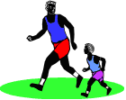

Ilford AC youngsters took part in two leagues this year. Newly promoted to UKYAL Division 1 and re-entry into the EYAL. Over 40 athletes competed for the club in the ten meetings that were as far a field as Eastbourne and as close as Mile End to our home track. The UKYAL meetings were very tough as the competition level was raised from the lower league. As we didn't always field a team of over 30 we were always up against it at these meetings and found the going hard. Unfortunately Ilford A.C were to end the season in relegation and subsequently relegated back to Division.2, however, I have no doubts that with the increasing numbers of athletes joining the club that we will bounce straight back up again at the first attempt.

The EYAL meetings it were run on as one division instead of the two of previous years. Consequently we met many teams that were of better quality than the inexperienced Ilford team. However, I believe we coped admirably in the process. Ilford put up a much better and stronger fight in this league and were able to be pleased with our first attempt back in the mix with a creditable 17 ish place out of 26 teams.

Now to the performances. Ilford A.C witnessed many club records being set this year with some outstanding performances. In the U/13 girls Aimee Jones was to twice break the 800m record that had stood for 8 years. Her time of 2min 37.8sec was very good and she continues to show quality in her running. Shanise Anderson and Laura Townsend had battles this year in the U/15 girls 300m with Shanise again setting a club record with a time of - 43.8sec. In the U/13 boys the continuing improvement of Jerrell Alleyne was clear to see. Most of the events that he participated in turned out to be win after win. The performances reflected this and although he didn't break sprinting records, in which he was always coming first, he did however claim club records in High Jump - 1m 40cm, Long Jump - 4m 81cm and was part of the 4x100m relay team. Simeon Stuart U/15 in growing in confidence and was very much present in most of the outings. He's highlighted must be the height he cleared in the high jump. A height of 1m 70cm was enough to equal the club

Parents Parents Parents
As a result of our recent successful recruitment drives we have an influx of over 70 new members, many of which are youngsters, training at the club.
This has put extra demands on the time of our coaches. We need your help……………don’t sit in the stands and freeze………come and join in . We need more coaches officials and helpers.
Any help would be most welcome …. Think about it eh?

record that had stood since 1972 by D.Hewitt. More to come from Stuart next year. The other memorable performances have nothing but admiration written all over them and that is for the U/17 Boys. Let's start with Aaron Balogun. He has competed both for the juniors and the senior men this season with a quite outstanding performance in the 200m with a time of - 22.45sec which beat the club record that had stood for nearly 20 years. He also grabbed a gold medal at the Essex track and field championships earlier this year. Gary Smallman was also to have a very good year culminating in a club record in the 400m with a time of 50.2sec which had previously stood for 21 years. He was also to bag a gold medal at the Essex champs. Along with Ekow and Joseph Perry (who also won a medal at the Essex champs in the 100m with a bronze) they had a brilliant and quite unstoppable season in the 4x100m relay. They won gold at the Essex champs relays and after being invited by UK athletics, competed at the Dom Valley Stadium in Sheffield for an invitational race in which they won silver.

As you can see although there was misfortune in being relegated, I can honestly say the athletes worked well this season and what hasn't been put down is the numerous other club records or countless numbers of PB's that they continued to set throughout the season. There was also a record number of athletes competing in one meeting at home which rose to the dizzy heights of 41 participants. If we as a club keep on striving onwards and upwards I am sure that Ilford A.C can be a force to be reckoned with for now and the future.

Finally I would like to mention the work that Mike Sargeant has put into these athletes well before I came onto the scene and continued to do so earlier on this season. However you will all know that Mike hasn't been very well over recent months and I am sure that you all would like to wish him the speediest of recoveries so he can do what he does and loves best.

I therefore dedicate this report to MIKE SARGEANT, get well soon.

WINTER TROPHY 2005/2006 (CURRENT STANDINGS)
MEN
Pos | Name | Age if vet | Vet |  |  |  |  | Total
Pos | Name | Age if vet | Bonus | Loughton | Chelmsford | Basildon | Great Notley | Points
1 | Martin Clarke | 53 | 46 | 16 | 18 | 17 | 15 | 112
2 | Graham Williams | 65 | 70 | 0 | 12 | 12 | 11 | 105
3 | John Platt | 52 | 44 | 14 | 16 | 15 | 13 | 102
4 | Jim McNamee | 65 | 70 | 0 | 0 | 11 | 0 | 81
5 | Malcolm Muir |  |  | 20 | 20 | 19 | 18 | 77
6 | Mick Herring | 60 | 60 | 0 | 15 | 0 | 0 | 75
7 | John Mackenzie | 51 | 42 | 0 | 17 | 16 | 0 | 75
8 | Tony Nixon | 57 | 54 |  |  |  | 16 | 70
9 | Andy Catton | 52 | 44 | 0 | 0 | 0 | 17 | 61
10 | Henry Ricketts |  |  | 13 | 14 | 14 | 12 | 53
11 | Darren Bottrill |  |  | 15 | 19 | 18 | 0 | 52
12 | Pete Whiting | 44 | 28 | 0 | 11 | 0 | 0 | 39
13 | Duncan Turner |  |  | 12 | 13 | 13 | 0 | 38
14 | John MacDonald |  |  | 19 | 0 | 0 | 0 | 19
15 | Rob Nixon |  |  |  |  |  | 19 | 19
16 | Matthew Maple |  |  | 18 | 0 | 0 | 0 | 18
17 | Matthew Herbert |  |  | 17 | 0 | 0 | 0 | 17
18 | Wesley Charles |  |  | 0 | 0 | 0 | 14 | 14
19 | Oliver Hock |  |  | 11 | 0 | 0 | 0 | 11
WOMEN
Pos | Name |  |  |  |  |  |  | Total
 |  |  |  | Loughton | Chelmsford | Basildon | Great Notley | Points
1 | Breege Nordin |  |  | 10 | 10 | 10 | 10 | 40
2 | Keelie Brooks |  |  | 9 | 8 | 9 | 9 | 35
3 | Pam Jones |  |  | 7 | 5 | 7 | 7 | 26
4 | Sally Gillam |  |  | 0 | 6 | 6 | 8 | 20
5 | Nicola Hopkinson |  |  | 0 | 9 | 8 | 0 | 17
6 | Pauline Tester |  |  | 8 | 0 | 0 | 0 | 8
7 | Lyndsay Barker |  |  | 0 | 7 | 0 | 0 | 7

Club Awards 2005

W S ATKINS CUPS - awarded for most points scored in Women’s Southern League Matches
Senior Ladies Track Events – Clare Thake
Field Events – Clare Thake
Intermediate Ladies Track Events Vanessa Samuels
Field Events – Jessica Manning
Girls Track Events – Sarah Kigozi
Field Events – Juliana Dougan
ILFORD AC PLAQUE- Coaches award for the best athlete in Women’s Southern League – Sarah Kigozi
LYNNE KENDALL TROPHY – Overall points scored in Women’s Southern T$F League – Sarah Kigozi
ALF PELLS TROPHY – Club hurdler of the year – Matt Maple
BUSHNELL TROPHY – Club Thrower of the year – Craig Burrow
ENDEAVOUR CUP – Christine Higgins
FALLON TROPHY – outstanding club athlete of the year – Aaron Balogun
HOLDSTOCK TROPHY – best male junior in track and field – Gary Smallman
LAURENCE BROWN MEMORIAL TROPHY – most points scored by an 11-15 year old in club champs – Osi Nzeako
LOCKWOOD CUP – services to club coaching – Craig Burrowl
MASON-FORD TROPHY – most points scored by a boy in Young Athletes Leagues – Jerrell Alleyne
JOHN FILMER MEMORIAL TROPHY –
Senior Ladies 200m – Clare Thake
Senior Ladies 800m –Sally Gillam
ERIC AYLING CUP –
Senior Men 800m –John MacDonald
Senior Men 1500m – Malcolm Muir

Senior Men 3000m – Malcolm Muir
BILL COCKLE TROPHY –

Senior Men 5000m – Amin Koikai
ILFORD AC “ATHLETE OF THE YEAR” –Malcolm Muir
DSI DIGITAL AWARD WINNERS 2005

Female winners

1st Sarah Kigozi
2nd Rachael Giwa
3rd Laura Townsend

Male winners

1st Jerrell Alleyne
2nd Bakr Al-Akku
3rd Simeon Stuart

Train Like a Champion
With a Champion
Terry Knightley (Adv Dip.PT,NASM PT3.MRNT)

Achieve Your Ultimate Fitness Levels Get Fit for Life
Lose Weight & Reduce Fat Be a Perfect 10

Terry will motivate you to reach your dream fitness goals & weight with a focussed, personalised training schedule, nutritional guidance and essential body fat & calorie burning exercises

For a free consultation and to discuss your goals telephone Terry on 0794-1347323
Signature Tunes
Following the almost silent clamour formore following the article entitled “Things People would never say “ The Blue now gives you signature tunes – song titles that say something about your running mates

Again the Disclaimer – If anyone gets offended its nothing to do with me – Martin Well actually I have had a lot more entries but can only printthe following

Living in a box – Andy Catton

Walk Tall – John Platt
Big John
Making your mind up

I can see clearly now

I can see for miles – Ashley Pearce

Win, Lose or Draw – Peter Clinch

Ride Sally Ride – Martin Clarke
Smack my bitch up

Words don’t come easy to me – Malcolm Muir

Yeah Yeah Yeah Yeah – Matt Maple

Why? – Cocky Wilson

All I want for Christmas is my 2 front teeth – Terry Knightley

Mirror in the Bathroom – Darren Bottrill

Smooth Operator – Marc Delea

Selection from Hair - Wayne Hick

Wide Boy – Neal Keane

Every Breath I take – Peter Spelman

Football Crazy – Jim McNamee

I can’t dance – Pete Whiting

Money’s too tight to mention – Brian Moon

No that’s it I really must draw the line now - Ed


5
DON’T FORGET - | NEED YOUR EMAIL ADDRESSES

If you are not on the main distribution list i.e. If you do not receive any of the Ilford AC press reports from me via Email please send me your Email address to MartClarke@aol.com . You will then receive all the Ilford AC news plus an online copy of this magazine

Martin
GREAT QUOTES OF THE YEAR

Peter Spelman to Keelie Brookes …..”I’m afraid I’ve entered a few women I shouldn’t have”.
TRACK AND FIELD

Men’s Southern League, Division 1
2005
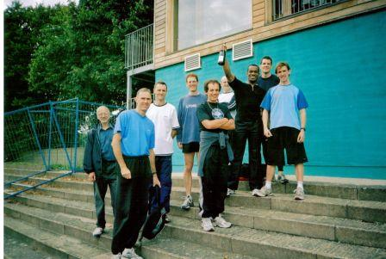

We survived again. And after 6 matches, 142.32 kilometres of running, 1380 metres of throwing (give or take a few metres) and untold leaping, combined with three minibuses dashing, two 5000 metres runners running and a heartbreak in the Lower Lea, we ended up in the same position as last year. But this does not tell the story of an exceptional year of athletics and the promise of brighter years to come. Could we entertain future year's of British League hopes? Only time and more seasons of effort will tell.
The success story for the year was the efforts of the sprints group of Ekow Quagraine, Aaron Balogun, Gary Smallman, Joseph Perry, Dan Grant, Terry Driver, Jon Manning, Francis Okwei-Nortey and Bakr Al-Akku who undoubtedly made waves in the league. Two under-17 club records were broken during league matches (Aaron Balogun in the 200 metres and Gary Smallman in the 400 metres) and many points scored. Aaron went onto improve his 200m time and the squad of Ekow, Aaron, Gary and Joseph went onto get a silver in the AAA 4x100m with a club record of 43.44 seconds.
Other highlights include some excellent performances from Sam Malekout who is becoming an indispensable part of the squad, with all round talent and an increasing ability in the javelin (40.41 metres). John MacDonald also showed some of the magic of former years (season's best of 4:12.6), with some thrilling races which more often than not built up from a near jog, to a scorch up in the final lap. John's capacity to match this pace, despite a limited amount of training shows his natural ability. The emergence of Dave Amroon was also welcome with some gutsy running and no small amount of talent given his limited time in the sport.
We were also treated to a fleeting glimpse of Amin Koikai and Iain Wilson running in tandem through a biblical storm at Ashford. Tony Nixon showed some rarely seen last lap magic in the 1500 metres at Basingstoke (5:09.4), which was also a treat as was Craig Burrow's consistent throwing, which so often proved to be make or break as the discus dictated the marginal results at the end of each match. Malcolm's 5th match performance at Bracknell to record season's bests of 16.03.3 in the 5000 metres and 10:24.0 in the steeplechase could only be surpassed by his offer of completing the 4x400 metres team.
Given the weakness that Ilford has had in the jumps in recent years, there were some encouraging signs of progress. This would be further improved if the Southern League can see it in their hearts to move the bloody triple jump away from the 400 metres, so Gary doesn't have to finish each race with a hop, skip and a jump. With youngsters such as club record holder Simeon Stuart coming through the ranks, the squad of Jason Bartley, Sam Malekout, Aaron Balogun, Gary Smallman and Pete Whiting (assuming he doesn't get called up for national pole vault coaching duties) will be further bolstered.
The throws continue to be strong with Sol Anwar finding some excellent late season form (season's best of 13.38m), Wesley Clarke (saved his best for an open but recorded 44.70m in the league) and Craig Burrow (11.90m shot, 39.79m discus, 35.15m hammer and 49.10m javelin). Pete Whiting continues to surprise in his latter senior years with some excellent javelin throwing.
Our greatest hurdle is finding some, well ...... hurdlers. Since the loss of our Polish high hurdles wizard, the team has been relying on the efforts of stand-in athletes. And there are sizeable gaps in the middle distance. Rob Nixon has had an injury troubled season and the good performances of runners such as Malcolm Muir, John MacDonald, Dave Amroon, Ashley Pearce, Iain MacDonald and Matt Maple are not enough to pick up sizeable points in this area. Despite some excellent talent in the 400 metres, the quarter mile relay ... well lets just not go there.
As manager, I was constantly surprised and delighted with the performances of the athletes, but even more so, by the commitment of all athletes, not one of whom I could suggest didn't give their all at any time. It is with this spirit, that I believe the team will go on to much greater things.
So a quick run down of the meetings:
Match 1 - 7th May, Ashford
Success story The 4x100m squad start as they mean to go on with an excellent 44.4 seconds. Craig throws a season's best 49.10 metres in the javelin and Jason Bartley throwing an excellent 9.76 metres in the shot. Ashley Pearce and Iain MacDonald score excellent personal bests in the 1500 metres (4:35.3) and 800 metres (2:18.5) respectively, Ashley running John down fast over the last 400 metres.
Moment of disaster Relatively peaceful save for a spot of rain in the 5000 metres
The crunch Craig and Jason score 8 points between them to finish 3rd, 3.5 points ahead of Harrow
Final scores Ashford 129, Reading 127, Ilford 95, Harrow 91.5, Blackheath and Bromley 84.5
Match 2 - 21st May, Plaistow
Success story Okay it's the 4x100 metres squad again with 44 dead. Also Gary gets a personal best in the triple jump (11.82 metres) and Craig gets a season's best in the discus (39.79 metres).
Moment of disaster Where to start: the 5000 metre starter starts a race with 2 runners, despite the heaviest rainfall since Noah said those immortal words, 'has anyone seen my hammer and rubber sealant' ('rules are rules ...'), Francis was introduced to 400m hurdling with a bump (sorry Francis), and we had a couple of disqualifications due to lane infringements (well if you're going to get all funny about it). We then lose to Enfield (they of the 5000 metre entrants) by two points. Oh and who was going to call Dunstan.
The crunch Match official hides in the portakabin and refuses to give into the protests of Catton and Nixon.
Final scores Newham and Essex Beagles 125, Milton Keynes 115, Enfield and Haringey 98, Ilford 96, Bournemouth 70
Match 3 - 25th June, Aylesbury
Success story Undoubtedly the club records by Gary in the 400 metres (50.2s) and Aaron in the 200 metres (22.5s). Not to be outdone, John MacDonald and Dave Amroon get seasons bests in the 800m (2:02.6 and 2:05.8 respectively), with Dave running so hard that his jacket potato brunch paid him another visit. Jon Manning's 400 metres (52.4s) should not be forgotten.
Moment of disaster Where's the team?? Where's the pole vault bar? Pete and Matt faced with a pole vault competition with no extender bars, oh and no pole vault pole. Ilford take 'just in time engineering' to its limits, as exemplified by Malcolm running to the start with the only man who can keep up with him, Tony Nixon pinning his number on.
The crunch Successfully begging Sol to make a comeback, repaid with an excellent 12.99 metres in the shot.
Final scores Yeovil 150 (woof), Aylesbury 117, Ilford 93.5, Luton 85.5, Tonbridge 84
Match 4 - 9th July Basingstoke
Success story Jason Bartley leaps to 1.70m in the high jump to restore Ilford leaping pride. Aaron and Gary respond with leaps of 6.39 metres and 11.98 metres in the long and triple jumps to make the day one of leaping joy. Sol Anwar breaks magic 13 metres mark with 13.29 metres in the shot putt. Ekow Quagraine in majestic form with 11.4 / 23.3 in the 100 / 200 metres
Moment of disaster I assure you that driving to Basingstoke is being used as a form of torture. Matt makes Andy chortle after 95mph journey in the mini-bus to get to first event. Andy gets revenge as the RAC routefinder sends Maple around the bend.
The crunch More discus magic with Sol (37.32 metres) and Craig (36.45 metres) nearly hit the maximum score with 9 points. Also turning the map the right way up helped too.
Final scores Winchester 132.5, Windsor etc etc etc 118, Ilford 106 (more woof with only score over 100), Nene Valley Harriers 100.5, London Heathside 59
Match 5 - 30th July, Bracknell
Success story Malcolm Muir excels for a total of 2 points in the 5000 metres (16:03.3) and steeplechase (10:24.0). John pulls one out with 4:12, Darren Bottrill makes 5000 metres debut, Sam Malekout works wonders with the pole vault with 2.40 metres and Matt Maple upsets Aldershot 'plans'* with personal best of 64.1s in the 400 metres hurdles.
Moment of disaster One of our 800 metres runners is missing. And arriving in Bracknell - enough to raise the fear of God in any sensitive athlete.
The crunch Thought we had lost match by one point, only to discover that due to an adding error, we find that we actually finished 4th by the same margin.
Final scores (toughest match of the season) Highgate 138, Havering Mayesbrook 126, Exeter 102, Ilford 86, Aldershot etc 85
*Aldershot B string runner runs 15 seconds faster than A string runner!
Match 6 - 20th August, Ilford
Success story Bakr and Elijah make their debuts with flying colours. Aaron gets a personal best in the 100 metres (11.2s). Sol tops previous performance in the shot (13.38 metres). Roger Honey demonstrates how to do high hurdles (20.2). Ilford guarantee top flight competition next year.
Moment of disaster Disasters? No, I think we've got the hang of this now. Unless you include the state of some of the athletes later that evening. I have photographic evidence...
The crunch Not having to drive anywhere. Phew!
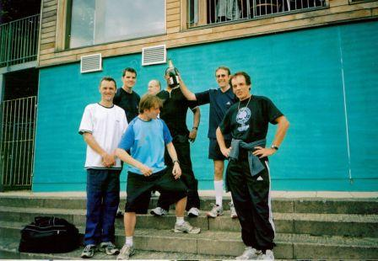Final scores Basingstoke 148, Dartford 126, Ilford 98, Woking 84, Serpentine 74
Matt Maple 14 Dec 2005

LOCAL RUNNERS STAR PROFILE

NAME: MARK-GAMBLE-THOMPSON

Introducing a new feature on local star runners you have seen around the circuit we open with Mark Gamble-Thompson of Colchester Harriers. I apologise to Mark as he completed the questionnaire last year just missing the deadline of last year’s club magazine. Some of the information he has supplied may therefore be out of date. I know for a fact that he has recently become the Parachute Regiment overall champion and veteran champion of the Royal Artillery and had a best ever finish of 5th in this year’s County veteran championships. In keeping with the family tradition Mark’s son Lewis has also developed into a very fine athlete and has been making a name for himself in the County.

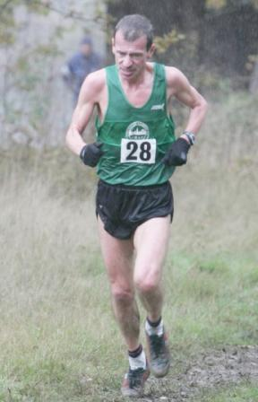
AGE: 44
CLUB: Colchester Harriers
OCCUPATION: Army Captain
WHAT YEAR DID YOU START RUNNING?
1976-1985 2000-current
WHY DID YOU START RUNNING?
Father – See Profile Sheet
PERSONAL BESTS
As a veteran Year
Track:
800metres
1,500 metres
1 mile
3000 metres
5000 metres 16.05 2004
10000 metres

Road
1mile
5miles 27.30 Great Bentley 2002
10k 33.12 Felsted 2004
10miles 55.49 Hartlepool 2004
Half Marathon 74.35 Fleet 2004
20 miles
Marathon 2.39 Manchester 2002

WHAT CHAMPIONSHIPS AND MAJOR RACES HAVE YOU WON ALONG THE YEARS?
Army veteran half marathon champion 2002 & 2003
Army veteran cross country champion 2002
Essex veteran 10k champion 2004
FAVOURITE RACE AND WHY?
Fleet half marathon – Army champs. \good experiences
BEST PERFORMANCE?
2.39 in Manchester Marathon 2002
33.12 in Felsted 2004
WORST EXPERIENCE IN RUNNING?
London Marathon 2003. Blew up for no apparent reason at 13 miles and finished in 2.52
WORST INJURIES SUFFERED THROUGH RUNNING?
Achilles Summer 2004
GREATEST RIVAL?
Woodford Green Veterans
FAVOURITE OTHER RUNNER (BRITISH)? Paula Radcliffe
(FOREIGN)? Gebresellasie
TYPICAL WEEKS TRAINING?
45-50 miles
Coached by Mel Smith
WHAT OTHER SPORTS DO YOU DO?
None
FAVOURITE FILMS?
Great Escape
WORST FILM?
The Exorcist
FAVOURITE TYPES OF MUSIC?
Beatles, Robbie Williams
FINALLY ONE PIECE OF ADVICE YOU WOULD GIVE TO ANY RUNNER TRYING TO IMPROVE?
Train Hard:Win Easy but remember recovery runs are there for a reason.
CLAIM TO FAME?
Beat Steve Cram in 1976.
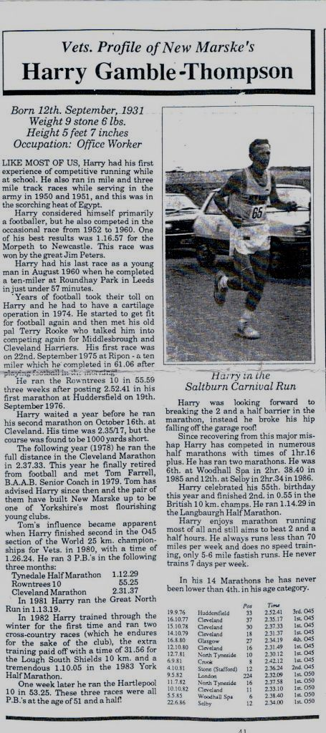

Great News for Oldies

Latet research suggests that the onset of age doesn’t have to mean a great drop in performance. Older runners are faster year on year and are showing considerably faster times than their counterparts 20 years ago. The report in the British journal of sports Medicine analysed the running times and age of the 415,000 men and women who took part in the New York marathons from 1983-1999. Of the groups of runners investigated the greatest improvements have occurred in groups over 40 years old.

There may be many possible reasons for this, social factors, diet, or training knowledge. If individuals stay active throughout their life, the reports suggest that times for the upper age groups will keep on decreasing. Vets will see improvements at an equal, if not greater rate than the younger athletes. However some aspects of ageing are a fact: metabolism slows down, heart rate drops, muscle power is reduced. Training does slow these changes.

A gym session is a sensible option to do. It can strengthen and help to reduce injuries which come with the onset of age. So a slight adjustment in your training can see you run for many years. Remembe - your body adapts.

Jargon Explained - What is VO2max?

If exercising for more than two to three minutes continuously, energy (the body’s carbohydrate-glycogen) will be supplied aerobically, or with oxygen. Of course the more oxygen you can consume (and supply to working muscles), the greater your energy supply, the longer you can keep exercising. The fitter you are.

So the exercise intensity keeps rising and the minutes tick by. You will reach a point where you are consuming as much oxygen as you can. No matter how hard you try. At this point you have reached your VO2max.

In other words VO2max means a measure of the maximum (max) volume(v) of oxygen (O2) you can consume during physical activity. Tests are spread out over months and years when used with heart rates they form a way of monitoring an athlete’s progress

Caveat
Below one of Ilford’s premier “Oldies” Wayne Hick demonstrates the effects of getting the equation totally wrong - Apart from the premature hair-loss, the desire to perform Popeye impersonations is not so well documented.,

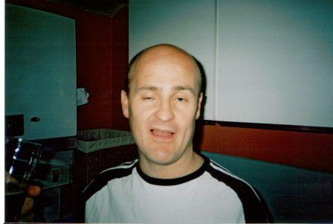

Marc Delea

Track Stats is the quarterly magazine of the National Union of Track Statisticians (NUTS) which nowadays is more of an athletic history magazine with the majority of the journal given over to historical articles.
Enclosed are the articles on Eileen and Phyllis.

Eileen Garritt – Blackeby WAAA Mile Champion 1949

Eileen, today a sprightly 81 years of age, won the WAAA Mile Championship at White City in 1949 by a staggering 120 yards and kindly agreed to answer some questions regarding her athletic experiences before during and after the Second World War. I have used Eileen’s own words.

Eileen became interested in athletics at school in the 1930’s. ‘Having been high jump champion at school I joined Ilford Athletic Club in 1939 to pursue this activity only to find my standard was rather low. A half mile handicap was held one evening which I won easily, pointing me to where I might have some talent.’

‘The war interrupted athletics and I joined the WRNS in 1942. Based at Staines working with the American Navy (great fun) and then moving to Chatham, where there was no opportunity for athletics. I landed in Ceylon (now Sri Lanka) on VE day 8th May 1945 spending a wonderfully exciting year in a beautiful country. There was the opportunity to play tennis for the WRNS and National Athletic Championships were held when I became Ceylon high jump champion at quite a low height and took part in relay and sprint events. Returning to England in May 1946 I eventually rejoined Ilford A.C. by this time 24 years of age!’

‘I cannot remember there being any proper regime as regards training for women middle distance runners until later when Ron Merrie took an interest in the women’s cross country athletes. He may well have been involved in distance runners on the track but I principally remember the Ilford women’s cross-country team meeting at his house in Loughton every Tuesday evening for training round the roads and then all dipping into the same bath (without Ron, of course!). Very fond memories of all the help Madge, his wife, and Ron gave us. They were wonderful.’

Ilford had a strong tradition of women’s cross country dating back to the beginnings of the event in 1925 and Madge Merrie, then Fulcher, competed for England in the very first international cross country race for women at Douai in France in 1931.

Eileen has strong feelings about the lack of recognition for her events – the mile and cross-country. ‘Oh definitely. Distance and cross-country running had minimal coverage in the press or recognition by the general public. Having won the National Junior Cross Country title, the National Mile and being a member of the first team to break the 3 X 880 yards and 3 x 800metres after the war I was picked to run for England in a cross-country race, only for this to be cancelled through lack of funds! I just accepted this, but remember Madge being incensed that we weren’t given our international badge.

Was there any thought of running longer distances? ‘Never! During my short career it was thought quite damaging for women to run long distances and cross-country races were restricted to no longer than three miles. The longest distance for women in the 1948 Olympic Games war 220 yards – so no place for distance runners. In fact, in my own case I would never have trained more than three times weekly or run more than one race a week for fear of over-doing it! The relaxed attitude probably prevented me from reaching my true potential. But absolutely no regrets – I thoroughly enjoyed it all.’

Have you followed women’s athletics since you finished your running career? ‘Not latterly. Glandular fever (1949/51) cut short my running career and I remember sitting in the middle of the White City track during the WAAA Championships not being able to defend my one-mile title. I did officiate at the WAAA Championships for many years afterwards. I married Laurie Blackeby in 1952 (a member of Cambridge Harriers) who continued pursuing his running, taking part in veterans events and we enjoyed a wonderful Masters Championships in Sweden in 1977 shortly before his untimely death. When the children arrived I found this fulfilling and there was no great desire to get involved actively again. I also developed many other interests. However, wonderful for those who did stay in athletics.’

Fondest memories? Oh! Many fondest memories. Great camaraderie. In 1946/52 athletics was a sport, not the science and the business it has become. We went to Laws (the maker of running spikes) to have our shoes made to measure and paid all our own expenses. There were no perks. When training and taking part in championships, often held at Chigwell Row (the Ilford AC Cross Country HQ,) there was the fun of endeavouring to get back first or as soon as possible. The reason? Edgar Moon would have filled three tin baths with hot water so there was the incentive to grab some of the ‘clean’ water to remove mud and dirt first. We often then had tea and went across to the hall (or was it a hut) for a social. Good home-made entertainment – simple and unsophisticated. Edgar and Betty, his wife, did such invaluable service for Ilford AC and women’s cross country in the county.’

‘In conclusion, I look back feeling it was a privilege to have been part of Ilford AC and so grateful for the friendships, fun and memories.’

Warren Roe meets another leading half-miler of the 1950s
A World record ? We can’t possibly have employees doing that sort of thing

Diane Leather and Joy Jordan were the dominant British women half-milers for almost a decade. Between them they won all but one of the nine WAAA finals contested between 1954 and 1962. Yet the one other champion at the event during that era outlasted both of them with a career which began in 1950 and continued for another 16 years. Phyllis Perkins (as she was known for much of her competitive career) won enough middle-distance honours to have ranked her behind only Kelly Holmes had she been born four decades later.

Phyl (formerly Miss Green) was WAAA champion at 880 yards in 1956 and 1963 and at the mile in 1954 and 1955. She was national cross-country champion in 1951, aged only 17, and again the following year, and was a member of Ilford Athletic Club’s winning team on six occasions from 1951 to 1960. She set a World record at 1500 metres and for the 3 x 880 yards relay. She set British records at two miles and for both the 3 x 880 yards and 3 x 800 metres relays. She ran in the 1960 Olympics and the 1962 European Championships. Her fastest 800 metres time of 2:07.3 was set in 1956 and ranked her 4th in the World for the year behind three Soviet athletes – including Nina Otkalenko, the current World record-holder and European champion, and Lyudmila Lysenko, a future World record-holder and Olympic champion.

Now Mrs Winger, and 70 years of age this year, Phyl looked back fondly on those achievements when I went to visit her and posed a series of questions on behalf of “Track Stats”. She joined the Ilford club at the age of 16 in 1950, and one of her earliest abiding memories is of winning the Southern and National cross-country titles in her first season and the excitement when the Ilford girls won the team races. Arriving back at Ilford Station from the National at midnight, she and her team-mates were met by the Mayor, a crowd of supporters and her parents. The other highlights included the 3 x 880 World record by the Ilford team in 1952, the 1500 metres World record at Hornchurch in 1956 and her international 800 metres debut the same year. She remembers competing against Valerie Ball on a number of occasions and reckons that the win/loss record between them was about even. There were many exciting finishes to their races and in 1951 Phyl was 2nd to Valerie in the Southern 440 final and then beat her in the South of the Thames v North of the Thames 880 with a personal best of 2:18.2. The following year there was an extremely close finish in the WAAA 880 when Margaret Taylor won in 2:17.5 by one-tenth from Enid Harding, with Phyl 3rd in 2:17.8.

Phyl was certainly disappointed in the early years of her career when she would be winning races on the domestic circuit and then see her contemporaries in other events going to the Olympics, the European Championships and Commonwealth Games, whilst the middle-distance runners stayed at home because their events were not recognised by the IAAF or the IOC. She was probably running at her best in the mid-1950s and there was no 800 metres for women at the Olympics from 1928 until Rome in 1960. She was selected for those Games after finishing a close 2nd to Joy Jordan at the WAAA Championships, but like most of the British middle-distance and long-distance runners she was affected by the hot weather and performed below her best. Medical research into acclimatisation recommended arriving either three weeks before the race or the day before, but the British team was flown out three days before. Phyl recalls how embarrassed she was sitting at home and missing the opening ceremony as the neighbours knew that she had been selected and could not understand why she was not in Rome !

When Phyl first joined the Ilford club she was coached by Ron Merrie, who looked after her in her successful early years as a runner on the track and cross-country. The club had a winning group that included Eileen Garritt and they trained three days a week on the local Port of London Authority grass track, practising starts and striding and lapping round the field. During the winter there were runs twice a week from the houses of two of the club’s keen supporters and a group run at the weekend from the Chigwell Row headquarters, involving Phyl in three different bus journeys to get there.

Typical sessions would involve a group of six or eight girls running round the Ilford roads for 30-45 minutes on a Tuesday evening and then another run of the same length with some of the Ilford men on a Thursday. Additionally, Phyl would run on the roads near her Hornchurch home, in Essex, on a Monday and Wednesday, sometimes with her father riding a bicycle alongside. There was plenty of road and cross-country competition of a high standard and the women had races most Saturdays. After a couple of years Ron Merrie felt that he could not progress Phyl’s career any further and recommended that she work with “Johnny” Johnston, who was coach to the marathon runner, Jim Peters, but this turned out not to be successful and after a year or so they parted company.

An approach was made to the AAA to find someone else and the national coach (and 1938 Empire Games mile champion) Jim Alford was introduced. A partnership was formed which lasted until 1966 when Phyl went to Brentwood Teacher Training College. Alford was living in Wales at the time and coached Phyl by letter and phone, meeting up with her every six weeks or so when his group congregated at Tooting Bec. The track was a hub of athletics in South London and was always packed with athletes. There was a strong group of women runners – including Pam Davies, Margaret Beckford, Carol Mitchell, Anne Smith, Pat Brown, Madeleine Wooller and Molly Hiscox – who initially trained by the light of hurricane-lamps. Sessions took place six days a week, and Phyl also sometimes ran in the early morning round the fields near her home and twice a week did a 20-minute run along the embankment in London, as well as playing netball in Lincoln’s Inn. Her training diaries show the following:

May 1956
Monday – On the road, 4 x 220 yards medium pace, 20 minutes speedplay, 4 x 150 yards fast stride.
Tuesday – On the track, 1½ miles medium/slow with last 300 yards fast, 5 x 100 yards crouch start in 12sec each with 300 yards walk/jog in between.
Wednesday – On the track, 660 yards in 1min 38sec, jog for 6min, 220 yards in 27sec.
Thursday – On the track, 4 x 50 yards fast stride, 6 x 30 yards starting practice fast, 4 x 150 yards fast stride with 330 yards jog in between.
Friday – Rest.
Saturday – Essex Championships, 220 yards (2nd) and 440 yards (1st 58.8).
Sunday – 6 x 100 yards medium/fast stride with 220 yards jog between.
Monday – 30 minutes speedplay with 3 x 150 yards and 3 x 300 yards fast stride.
Tuesday – Rest.
Wednesday – 1 mile race.

Thursday - 1½ miles steady slow with last 300 yards faster, 4 x 100 yards medium/fast with 220 yards jog between.

Friday – 440 yards in 61sec, 6 x 30 yards starting practice, 440 yards in 60.5sec.

Saturday – Rest.

January 1960
Monday – 880 yards slow, 880 yards medium, 440 yards slow, three laps good sustained effort, 440 yards slow, three laps good sustained effort, 440 yards slow.
Tuesday – 2 x 220 yards in 33sec with 220 yards jog between, 2 x 330 yards in 53sec with 220 yards jog between, 2 x 440 yards in 75sec with 220 yards jog between, 2 x 330 yards in 53sec with jog between, 2 x 220 yards in 33sec with 220 yards jog between.
Wednesday – 1 mile slow, 1 mile medium, 1 mile fairly fast, 880 slow.
Thursday – 3 x 330 yards in 53sec.
Friday – Rest.
Saturday – 45 minutes speedplay on country.
Sunday – Easy running.

All of these sessions would be preceded by an easy 2 miles warm-up run and exercises. There was also regular weight training and gym sessions. When Phyl lived in Hornchurch, she would go to the Tooting track straight from work, getting home at about 10.30 p.m., but she later moved to Mitcham, in Surrey, to be nearer to the Tooting track, and she lived there until going to college in 1966.

When she travelled abroad for competition Phyl found that the athletes in most other countries were “perpetual” students and thus had all the time to devote to training, whereas the British runners like her were having to hold down full-time jobs, travel to London for work, train after work, and get home late. The British thus felt like poor relations, but they also believed that they were performing pretty well in comparison, without the privileges their foreign rivals enjoyed. The observation that remains most vivid in Phyl’s mind is that when she was competing in Eastern Europe, as she often did, her competitors were full-time athletes paid by the state, often provided with a flat and a car, and living much of the time at a sports centre. Phyl knew nothing about Eastern Europeans taking drugs in the 1950s or 1960s, and there was never any talk of it, but now she feels one can always reflect on the sudden improvement in some athletes and wonder. For a meeting at the White City athletes would arrive on the underground train and walk from the station to the stadium, but that was just accepted as there was no alternative. Everything depended on a good performance, and it was always felt that if you had a poor run you would not be picked for the next international. Awaiting the team announcements in the national newspapers was a nightmare – what if you hadn’t been chosen ! Nobody expected to receive anything other than a GB tracksuit top and a plaque, though sometimes the sponsors, the “News of the World”, would give a presentation memento, such as a cut-glass dish.

Had she been running today, Phyl realises that the recognition, the financial gain, and the help she would have received athletics would have totally changed her life. She would have been able to train in a more structured way, though she feels that if training is your only life this may put more strain on the individual, whereas athletes in her era had other diversions to occupy them. There would be the thrill of reaching greater heights and achieving better performances now, but it may not be so much fun as there was a lot to be said for the camaraderie in club athletics in the 1950s and 1960s which would be missed today. Having said that, Phyl makes the point that athletics was her life, and that of her friends, and nothing was allowed to get in the way of a training session or a race. So perhaps under the present system, the sport would have been more rewarding. As to what she might have achieved in the current era she feels that it is always difficult to make comparisons, but she was generally ranked No.2 in Britain, and if this was the case today she would be running a second or so slower than Kelly Holmes, making her times worth under 2min. When Phyl was an international most European races were at the weekend and she had to take leave from work on the Friday and Monday for travelling. Most firms allowed only two weeks' annual holiday which had to be taken en bloc, and so temporary work was the only answer. One particular anecdote which Phyl recollects gives some understanding of what had to be endured. When she set a World best time for 1500 metres on the local Hornchurch track in 1956 there were reports in the national newspapers, and when she went into work (at a greeting-cards’ company) the following day she was called in by her manager and told that he could not have employees involved in running and she would have to stop !

Note: Warren Roe’s book, “A 75th Anniversary History of Ilford Athletic Club”, was published by the club in 1998.

 | Picked for the Team
 | The long periods of hard training have had their reward and each of these athletes has been chosen to represent ILFORD in the forthcoming National Championship. What are their names, where do they hail from and in what event will each compete ?
 | Clues
1 | Mr, Dykes hails from Seven Kings. Mr. Parker, who has been selected for the 100 metres, is neither Alan nor the young man from Barking. | 3 | Dave has been chosen to run in the 1500 metres.
2 | The Loughton man who will take part in the Long Jump is neither Fred Grant nor Mr. Conway. | 4 | Paul who comes from Goodmayes will not take part in either the 100 metres or the High Jump.

Use the grid below to work out your solution:-

 |  | Boyle | Conway | Dykes | Grant | Parker | Barking | Chadwell Heath | Goodmayes | Loughton | Seven Kings | 100 metres | 1500 metres | High Jump | Long Jump | Pole Vault
 | Alan
 | Paul
 | Dave
 | Fred
 | Ken
 | 100 metres
 | 1500 metres
 | High Jump
 | Long Jump
 | Pole Vault
 | Barking
 | Chadwell Heath
 | Goodmayes
 | Loughton
 | Seven Kings

 | Name | Surname | From | Event

.

